Document Export to filenet with CMIS connection
Click on List Repositories – Select required repository on Right side panel
Click Import Repository
Go to Imported Repository on infrastructure – CMIS connection
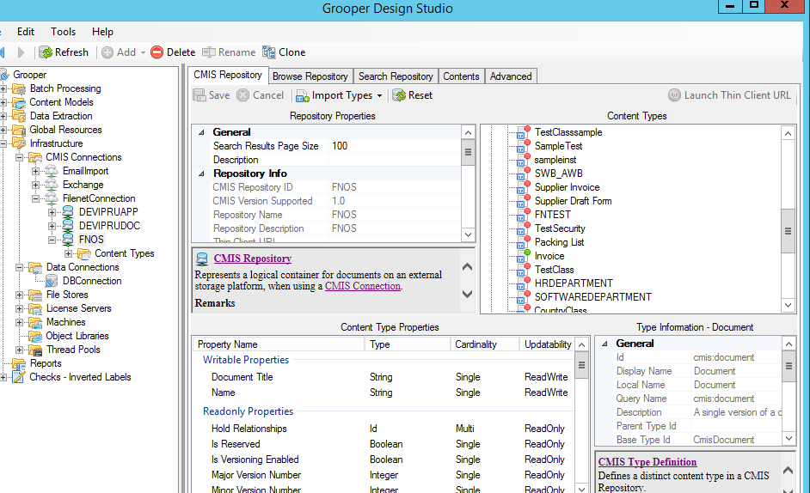
Select Import Types – and select Document class on Right hand side panel and go to import types and click Selected Type only
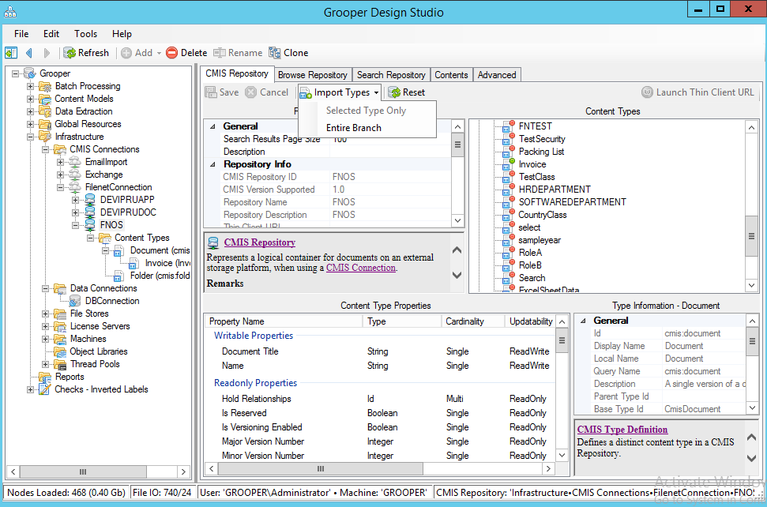
Go to CMIS – Particular Document class
Export enabled – True
Export Content Type – select required content model
Export Field mappings-
