Expense Reimbursement via AP with Bill.com & Expensify & QBO
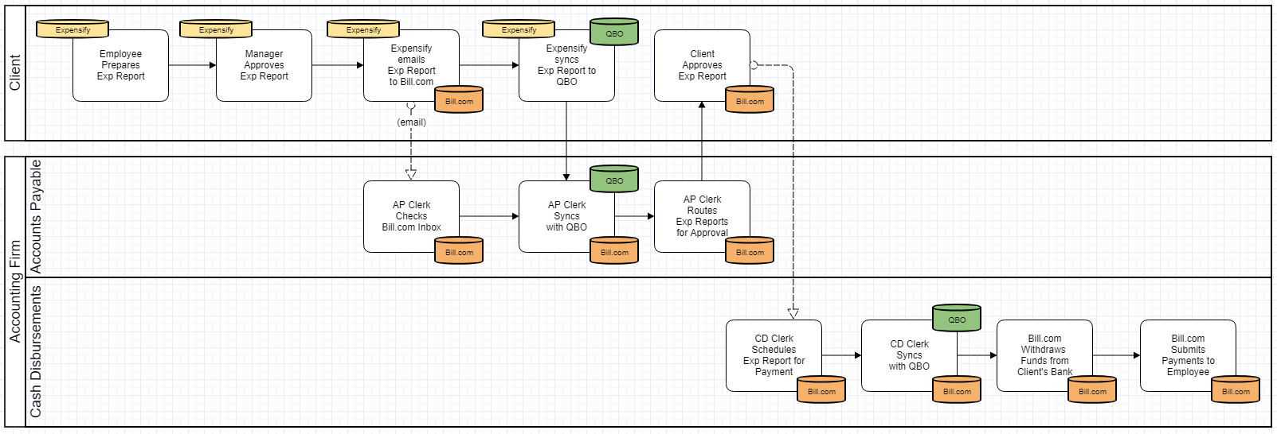
Expense Reimbursement via AP with Bill.com & Expensify & QBO - Process Considerations
- Accounting Firm is dependent upon Expensify users submitting expense reports to have data sync to Bill.com and QBO.
  - Considering adding a procedure to End of Month Close to check Clients' Expensify accounts to determine if there are any outstanding expenses that haven’t been submitted yet.
- The workflow above assumes that the firm’s staff is not involved in the Expensify process. If the client uses the Approval Mode called “Advanced Approval” then all approved expense reports can be flowed to a staff member (e.g. AP Clerk) to code before the report is synced to Bill.com and QBO.
  - Note that this will require the use of the Expensify Control subscription ($9/active user/month) rather than the Collect subscription ($5/active user/month).
- Submission of Expense Report by Client equates to approval of recording of liability
  - This assumes that the client is using the Approval Mode called “Submit and Approve” in Expensify. If the client is using “Submit and Close” then no approval was performed in Expensify.
  - Tip: Use Expensify’s ability to rename Chart of Accounts account names to a more user friendly name to improve users' ability to code themselves.
  - Expensify user accounts are cheaper than Bill.com user accounts, so when expense report approvers are not the same as bill approvers, we recommend that expense report approvers be provisioned Expensify accounts instead of Bill.com accounts. This also allows the approvers to use the rejection features in Expensify and send expenses back to Employees within Expensify for correction.
    - If expense report approvals are performed instead in Bill.com (i.e. no approval flow in Expensify), the drawback is that if an expense report is rejected, someone must inform the Employee since they are not part of the Bill.com workflow. Employees would then have to reopen their expense reports in Expensify, make the correction, then resubmit the expense report. The QBO transaction will re-sync (no duplicate created) and a PDF of the revised expense report will be published to the Bill.com inbox. The AP Clerk must know to check that the sync has occurred (so that any new coding, if applicable, is showing in Bill.com), detach and delete the rejected expense report, and then attach the revised expense report and then route it for approval again.
- When Expensify is linked to Bill.com and QBO, upon final approval of an expense report, the report is both published as a PDF to the Bill.com inbox and synced as an accounts payable transaction to QBO. The AP Clerk must then sync between Bill.com and QBO to bring the coded transaction in from QBO, and then attach the PDF to the transaction as the supporting document.
  - Note that as with other bills, the expense report’s coding can be changed in either QBO or Bill.com. These changes however cannot be synced back to Expensify. Because of this, we do not recommend that Expensify be considered a system of record.
  - When an expense report is published as an accounts payable entry to QBO, the email of the user that originated the expense report is used as the Vendor for the transaction. This means that all employees who submit expense reports will end up as Vendors in Bill.com too.
- Client approval of expense report in Bill.com is approval to pay
  - Tip: Develop cash disbursements policies / protocols with clients
- The process above shows single level of approval, but multiple levels of approvals can be captured serially via Bill.com on a bill by bill basis.
- The process above assumes that you are not using the ACH reimbursement feature in Expensify, and instead reimbursing using Bill.com. (Note that you can still get the Employee’s bank information and pay them via ACH in Bill.com by adding their ACH info to their Bill.com vendor record.
  - This provides more centralized control over cash disbursements and is particularly useful if money has to be transferred into the account from which disbursements will be funded.
  - Expensify processes each expense report reimbursement as individual ACH transactions. Versus when multiple expense reports are reimbursed via Bill.com, Bill.com will process all reimbursements processed for the same pay date as one ACH transaction.
    - Depending on the volume of expense reimbursements, the multiple ACH transactions generated by Expensify can make the bank reconciliation a challenge.
    - If your bank charges per transaction fees for ACH, then reimbursing via Expensify may increase the service charges you pay to your bank if there are a lot of expense reimbursements.
    - Expensify also processes ACH reimbursements with different timings (one to five days) depending on the dollar amounts of the transaction, which can make it difficult to inform employees exactly when they will receive their reimbursements. Versus Bill.com provides you with a predicable date that they will receive their reimbursements (whether by check or ACH).
      - More information on Expensify’s reimbursement timing can be found here: https://docs.expensify.com/reimbursement-timing
- Note: Bill.com automatically syncs once a day with QBO so manual sync step may not be needed unless you need QBO to be immediately updated after actions are taken (probably more important for cash disbursements since it impacts bank account balance).
Expense Reimbursement via AP with Bill.com & Expensify & QBO - Internal Control Considerations
- Remember to consider separation of duties related to:
  - Approval of expense report versus coding of expense reports and scheduling of reimbursements. Especially when the same staff person is coding expense reports and scheduling reimbursements, be sure that the same staff does not have the ability to approve expense reports. Otherwise that staff person could move a factitious expense report through to reimbursement without anyone else having touched the transaction.
  - Creation of new employees or changes to employee information (especially payment address and/or bank routing numbers) versus input of expense reports and scheduling of reimbursements. This is to ensure that a single person on your staff cannot create a factitious employee, assign real expense reports to that employee and have payments directed to themselves.
  - Changes to employee information (especially email, payment address and/or bank routing numbers). This is to prevent a staff member from changing the email and payment information for a real employee, to intercept the email notification that a payment was processed and the actual payment itself. Be sure that the person processing the expense reimbursements is also not the same person that employee would complain to if they didn’t receive their reimbursements.
  - Scheduling of reimbursements versus performing bank reconciliations. This is a standard internal control protocol.
Expense Reimbursement via AP with Bill.com & Expensify & QBO - Data & Document Flows
- Master data: Bill.com & QBO. The following master lists are synchronized between Bill.com and QBO. In the Bill.com Sync Preferences for each company you can choose whether QBO or Bill.com “wins” in the event of a conflicting change.
  - Chart of Accounts - Since this will have a potential impact on financial reporting and should not be changed without strong consideration we recommend QBO be the master for this data.
  - Vendor List - Since new vendors will often be first seen first via an incoming Bill. It may make sense to have Bill.com be the master for this data. However, this depends on whether the firm has a policy for obtaining W-9s before processing payment to vendors (to avoid the rush after the end of the year).
  - Locations - Since this will have a potential impact on financial and management reporting and should not be changed without strong consideration we recommend QBO be the master for this data.
  - Classes - Since this will have a potential impact on management reporting and should not be changed without strong consideration we recommend QBO be the master for this data.
- Master data: Expensify & QBO. The following master lists can be synchronized between Expensify and QBO: Chart of Accounts, Customer/Projects List, Locations, Classes, and Items. Expensify does not allow the editing of these lists in Expensify except for the Chart of Account names.
  - Chart of Accounts - Expensify allows you to override the name for a Chart of Account entry. This is so that you can put a “user friendly” name on the account to make it easier for users to code their expense reports.
    - If you change these names, you should keep a list of those you change because if you disconnect QBO and reconnect it, the names will revert back to the original names.
  - The Chart of Accounts is shown under the Categories area in the Expensify Policy Settings. All other master data is shown under the Tags area in the Expensify Policy Settings.
  - Note that you can turn “off” any Categories or Tags that would not be appropriate for Expense reports to reduce the list of options that users have (and reduce the risk of miscoding).
  - When configuring the Sync between Expensify and QBO, you can also select whether each master data list (Tag) is shown at the header level or line item level on the policy. Note that Bill.com does not support having Customers/Project at the line item level so if you plan to flow expense reports through Bill.com for coding review, you should not use the Customer/Project at the line item level in Expensify.
- Master data: Bill.com & Expensify. Master data is not synced between Expensify and BIll.com.
- Transaction data: Bill.com & QBO. The following transaction data sets are synchronized between Bill.com and QBO. In the Bill.com Sync Preferences for each company you can choose whether QBO or Bill.com “wins” in the event of a conflicting change.
  - Bills - Bills in Bill.com are synced to QBO as Bills in the QBO Expenses module. Bills entered into QBO also sync to Bill.com.
    - Note: There is an option for only sync Approved Bills to QBO. Once you turn this on in Bill.com you can’t turn it off. Bill.com says that you setting should ONLY be enabled if ALL bills will go through the Bill.com approval workflow. This setting might be helpful with a cash basis taxpayer if you can keep the time between the approval of the Bill and payment of the Bill small, as it would keep the amount shown in QBO’s Accounts Payable low while providing visibility into full potential liability in Bill.com.
  - Vendor Credits - Vendor Credits in Bill.com are synced to QBO as Vendor Credits in the QBO Expenses module. Vendor Credits entered into QBO also sync to Bill.com.
- Transaction data: Bill.com & Expensify. There are two options for submitting expense reports from Expensify to Bill.com.
  - Submit upon Final Approval. If you configure the Bill.com Connection in Expensify, Expensify will place PDFs of expense reports that complete the approval workflow into the Bill.com inbox. This will be done automatically by Expensify and the expense report will be put in a closed state in Expensify.
  - Manual Submit. You may also manually push the PDF to Bill.com by clicking the Sharing Options icon (see below) on the expense report and entering the appropriate Bill.com inbox email address.
    - 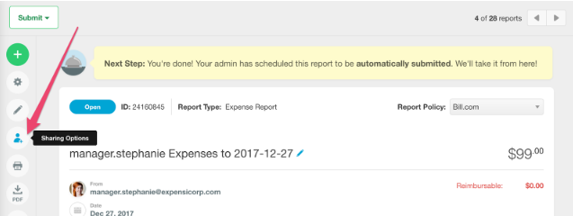
  - This submit method should only be used as a workaround if for some reason the direct connection does not work as there is a risk that a user will forget to submit the expense report to Bill.com or they may type in the Bill.com inbox email address incorrectly.
- Documents (images). When using this workflow, copies of all final expense reports will be stored in Bill.com under the employee that is the “vendor” for the expense report. Expensify does not attach copies of the expense reports when it syncs with QBO.

