Annotation lines

Internal line label A is by default a 2 point annotation line and Internal line label B is by default a 3 point annotation line.
A two point annotation line will control the length of the annotation, meaning the information will only plot between the two points of that line. 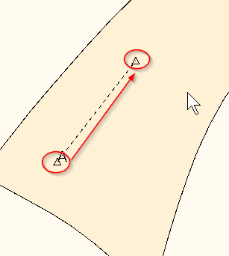

A 3 point annotation or a B line will control the height and width of the annotation, the 3 point line is usually in the shape of the letter L. Take that letter L shape and image it’s a rectangle or a square depending on how you drew it up and the text or annotation will only plot in that box.
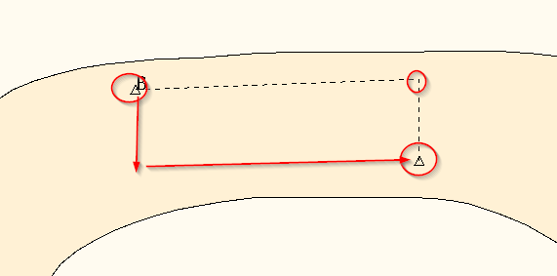

A and B are default lines, what that means is AccuMark already understands that annotation will plot on these lines.

Setting up the Annotation table.
When an AccuMark storage area is created an annotation table is created in that area, it is called A.
Open the A Annotation table in your storage area.
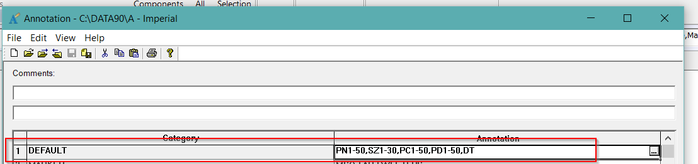
The information or the codes on the default line will automatically plot on an A or B annotation line. If you would like to change the information that will be plotted you can click on the square look up button and choose the information to plot.

