Uninstall and Reinstall and back Again

1. Uninstall the software from the control panel, uninstall all parts of AccuMark and Any other AccuMark features, AccuNest, MTM, AccuScan (anything AccuMark)
Problem and enhancement report utility
GTLM Security
Sentinel protection Installer
Sentinel Runtime

- Reboot
- Look in the c:drive for any other Accumark folders EXCEPT USERROOT, never delete Userroot, this folder contains the patterns
- Look in c:program files or program(x86)\ Delete the Gerber Technology Folder
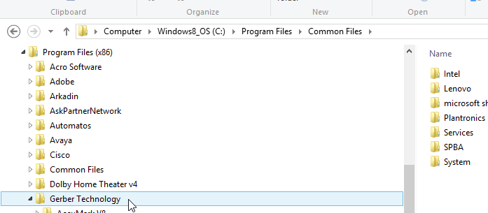

  - Look in C;\Program files or programs (X86)\Common Files, Delete the Gerber Technology folder in there.
  - 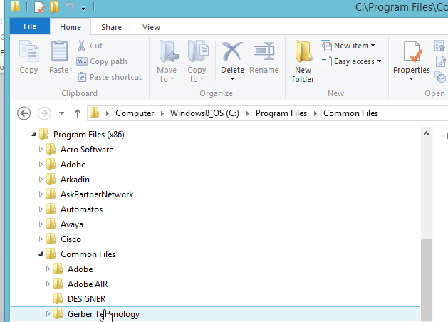
- After Deleting these files, Reboot
- Next look in the registry files and see if anything needs to be deleted. To access the Registry , click on the start button and in the search box type regedit, like in screen shot below. This will open the registry

- Once the registry is open expand the following folder, HKEY_CURRENT_USER\Software, Delete the two Gerber folders in there.

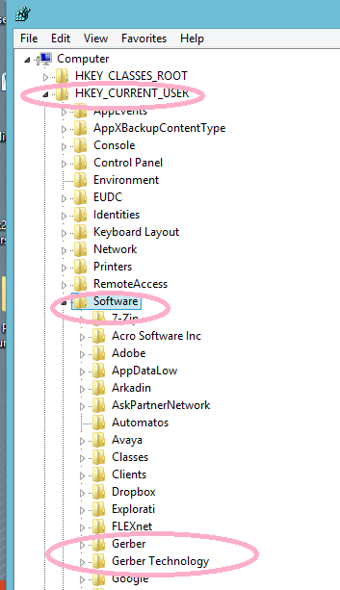
Also look in HKEY_LOCAL_MACHINE\Software\Wow6432Node\software
Delete the Gerber Folder.

- Reboot
- Reinstall software.

