- Log into Gerber University and click on “Sign up for AccuMark 101 Training” located under Virtual Training on the Home Page.
- You should land on the page listing all AccuMark 101 courses; click on a course name to continue.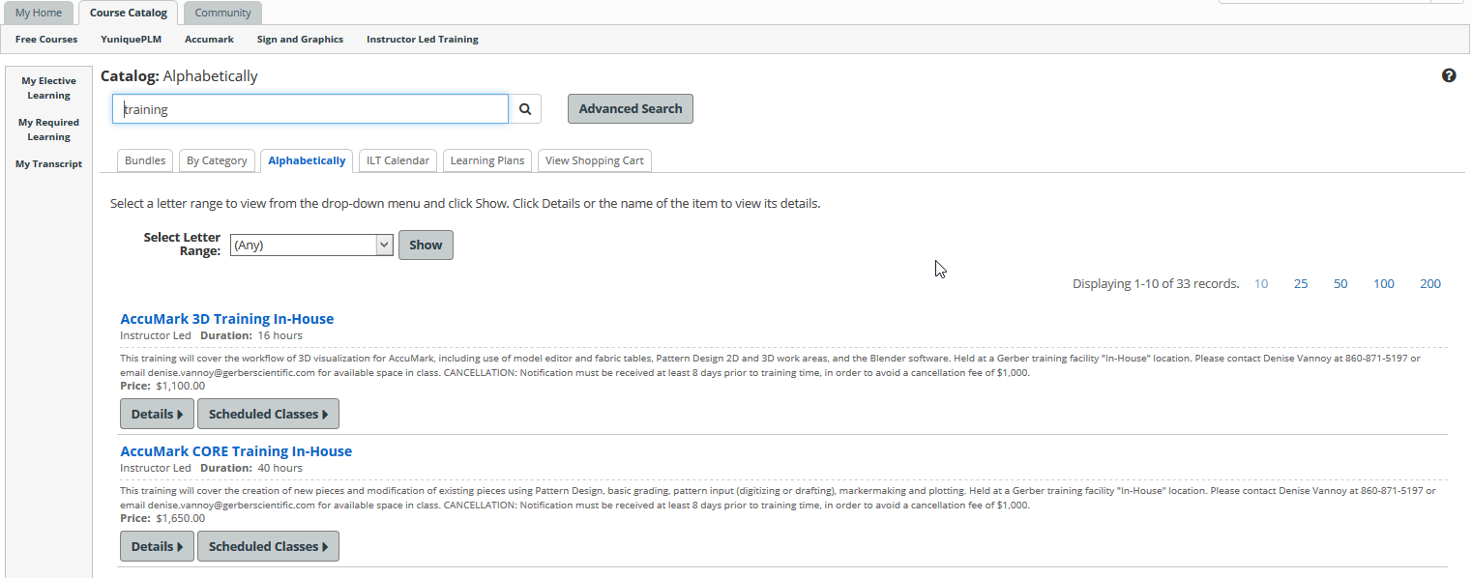
- On the course page, click on Purchase at the right side of the screen. 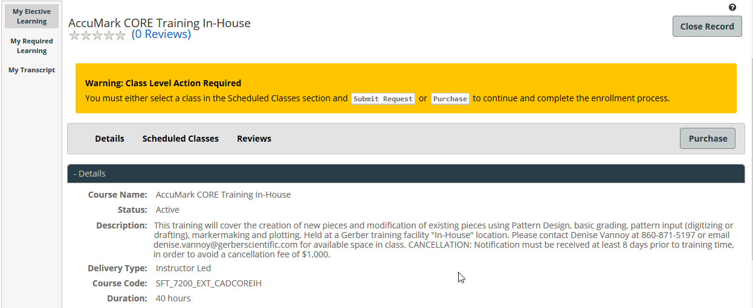
- Follow the steps for purchase.
  - Click on the Add to Cart radio button and then Next.
  - Verify your cart is correct, and then Proceed to Checkout.
  - On the Billing Information page, ensure that the information entered matches the card you are using. If you are using a card with information other than your GerberU profile information, you must change it to match the card, or the system may reject your purchase.
  - Click Submit.
  - On the Review Order/Billing Information page, click on Place Order. 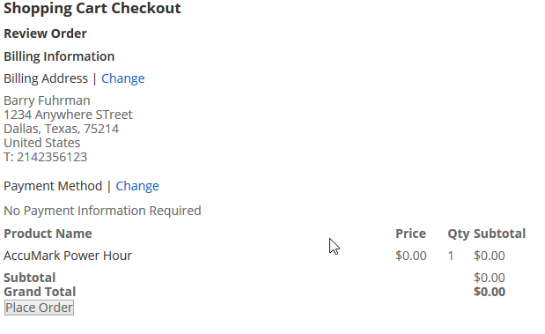
  - You should receive confirmation of the completed transaction.
- Once you have walked through the shopping cart steps, click on "My Transcript" at the left of the screen and find the course in your electives list. If you are returning to the site from a previous login, this can be accessed via Course Catalog > My Transcript. You can also use the search bar to narrow your search. 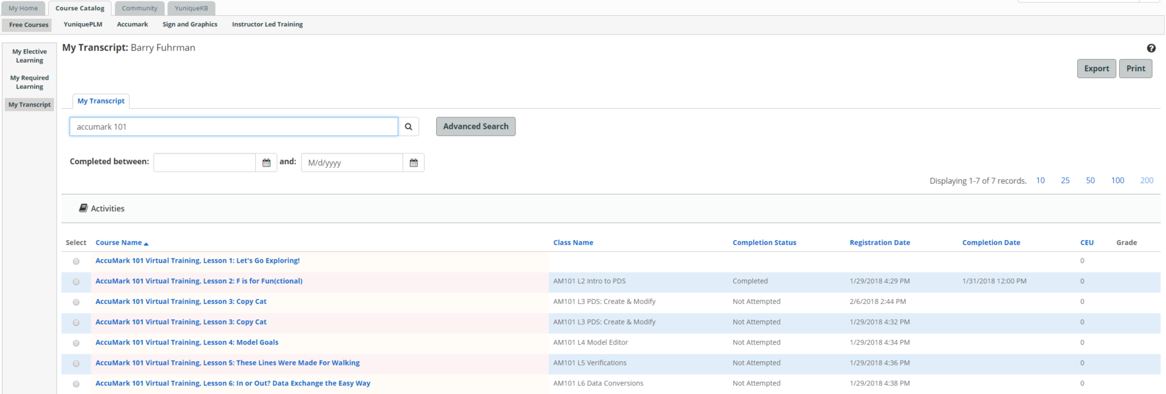
- Click on the course name and scroll down to available dates, where you will find the class AM101 followed by the lesson number and title. Select this class and click on Enroll.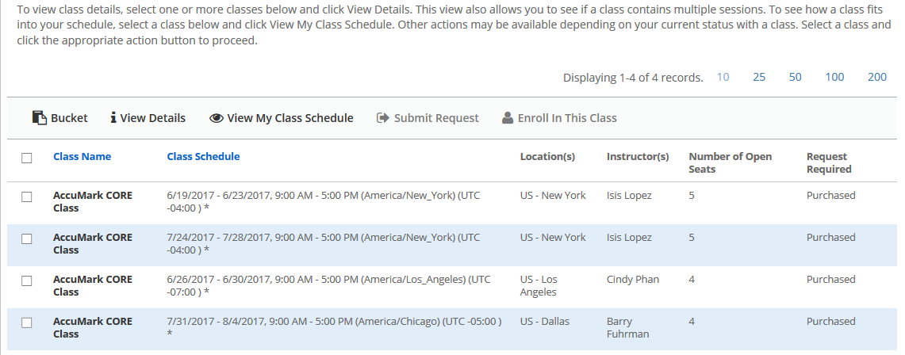
- You will be enrolled and should receive an email notification.
- From this page, you can also launch the class at the appropriate time using the Launch button at right, under Activities. If there are supplementary materials, they can be accessed here as well. 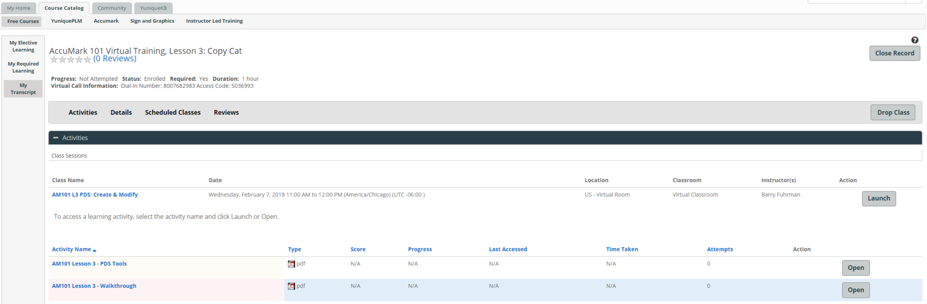
- Questions? Contact us at edu@gerbertechnology.com.

