THE MORNING FAT
MELTER PROGRAM
FREE EBOOK
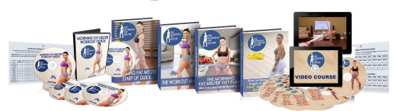
THIS IS A FREE REPORT!!
This short ebook is just an introduction to the
Morning Fat Melter program to give you an
idea on what you get when you order!
If you have already decided that you want to
lose over 20 pounds every month until you
reach your ideal weight, just use the button
bellow and check the complete Morning Fat
Melter Program right now!
Welcome to The Morning Fat Melter Program.
If you follow our program you can easily lose over 20
pounds of fat in the next 30 days, and burn fat evenwhile
you sleep!
All you need to do is do our easy morning workouts on your empty stomach and eat according to our easy to follow meal plan!
This has worked for thousands of women and will surely work for you too if you follow the plan that I laid out for you, so let’s get started!
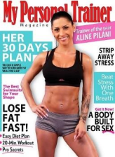
Who am I? Why I wrote this for you?
My name is Aline P.
I am a certified personal trainer and
nutritionist and have spent the last 10
years of my life helping women lose
weight, increase their health and
confidence.
I have spent years researching and
working with fitness experts, nutritionists
and dietitians to develop a weight loss
system that is so advanced and
effective that it is able to help all
woman reach their ideal weight.
And because of the amazing results my clients are getting with my program, My Personal Trainer Magazine has awarded me with "The Trainer Of The Year Award” in 2018.
Now, no matter your current fitness level, no matter if nothing has worked for you so far, and you fear that you will be overweight for the rest of your life, it’s time to start believing in yourself and expect for results!
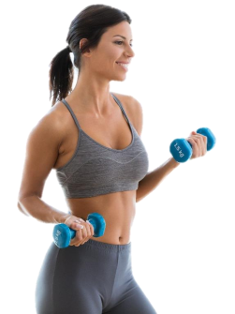
WHY MORNING WORKOUTS ON EMPTY STOMACH?
According to the British Journal of Nutrition, “women who
exercise early in the morning on their empty stomach, burn
almost 20% more fat than those who exercise LATER in the
day”.
This happens because on your empty stomach your body
taps into its existing fatty deposits to provide energy during
and after the workouts. The whole process accelerates
your metabolism drastically and keeps it elevated even up
to 48 hours after the workout ended.
This is also one way to make your body release insulin less
often, which improves blood flow to muscles and even
reduces the effect of eating foods that contain sugars
and carbs.
In the morning you have higher levels of Growth Hormone (GH) which helps your body build new muscles tissues, burn fat, and improve bone quality and longevity.
One study showed that 24 hours without food, increases the female growth hormone production by 1300 percent, so go ahead and do my first morning workout tomorrow morning, on your empty stomach!
HOW TO EAT FOR THE BEST
FAT LOSS RESULTS
The type of calories you eat will dramatically influence how
fast your metabolism runs, and if you lose or gain body fat, so
let’s start by talking about protein.
Why you should eat mostly protein?
Protein is the most important food for fat loss, because of a few reasons.
First is for the protein’s thermic effect. You see, your body will consume around 25% of the calories in those proteins simply to digest them.
That’s why, just by having a protein based diet, without eating fewer calories, a person can lose a considerable amount of fat.
The 2nd reason is that the excess protein, what your body does not use, will not be transformed into fat, but instead will be eliminated as waste, while access calories from carbs and fats will be stored as fats.
3RD -ly, protein, when consumed, helps to slow the entire digestion process down, even reduce your appetite and cravings, especially those late night cravings for sweets and carbs.
Protein helps to slow the digestion of the carbohydrates you eat as well, making your body stay out of fat storage mode.
The 4th reason is that by eating more protein you will build muscles. And each gram on muscles you have on your body will need 3 times more calories than a gram of fat.
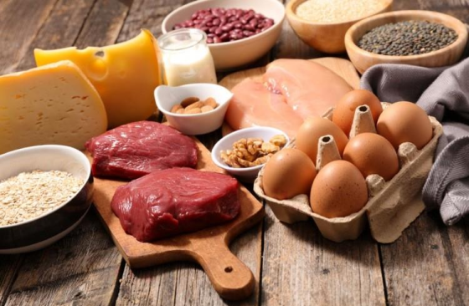
So here are the best sources of proteins:
- Free range poultry (chicken breast and turkey breast),
- Organic eggs (mostly egg whites because the yolk has a lot of fat),
- Wild caught salmon and White fish,
- Grass fed beef,
- Seafood like shrimp, scallops, crab and lobster,
- Low fat cottage cheese or string cheese & Plain low fat Greek yogurt,
- Whey protein powder (which by the way, you should drink after each workout, because it will go straight to
your muscles).
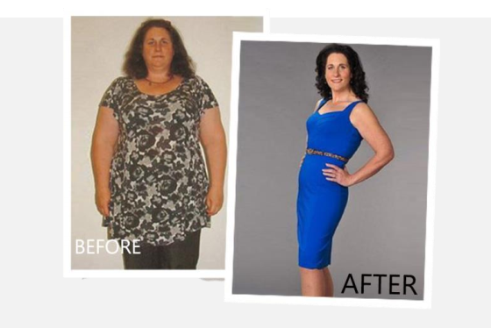
4 Powerful and Secret Nutrients That Triple Female Metabolism
I’ve discovered 4 powerful super herbs and nutrients that
double female metabolism and are capable of cleansing
your body of all toxins, metals, and acids and double your
energy level and make you feel 20 years younger, faster than
you may have imagined possible.
I still find it amazing that these 4 herbs and nutrients remain
such a secret. As you’ll see, adding them to your daily diet is
incredibly simple and the benefits, amazing!
They can increase your vitality, and your life span with at least
20 years of health, practically overnight.
Dawn lost 72 pounds in just 4 months just by adding them to
her meals, so if you want to check these 4 powerful but secret
herbs and nutrients,
How to eat carbs so that you’ll never gain weight
Everyone in the fitness industry may tell you that carbs are
bad for you and should be avoided if you want to lose
weight, however, this is not completely true.
Carbs are your biggest source of energy, and a great source
of vitamins, minerals and nutrients that your body needs to
survive, so we won’t give up on them during our plan.
If you’ve ever done a very low carb diet, you probably know
all too well how miserable it makes you and that’s why our
meal plan has the right amount of carbohydrates.
Another reason why carbs are important is the fact that they
regulate a very important hormone: Leptin.
Leptin is produced by your body’s fat cells and helps the
body monitor total fat stores as well as total calorie and
carbohydrate intake. When you eat fewer calories or less
carbohydrates, less leptin is going to be produced.
When this happens, the body then knows that it needs to do
whatever it can to get you to eat and gain weight.
Basically when Leptin levels fall too low, your life will be
miserable until you eat, but since we are keeping more
carbohydrates in your diet, Leptin levels won’t drop too low,
in fact they will be higher than normal, making fat loss so
much easier.
There are 2 types of carbohydrates, simple and complex.
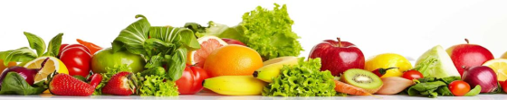
Simple carbohydrates, are the carbohydrates that will tend to
spike blood glucose levels, causing that high dose of insulin to
be released into the blood stream and leading you to gain
body fat.
So these simple carbs should be avoided and if you can’t stop
yourself from eating them, better have them in the morning
and early afternoon.
Simple carbs includes foods like:
White bread, Crackers, Chocolate bars, Candy,
Soda, Energy bars, Cereal bars, Sugary cereals,
Muffins, Cake, Cookies, Other baked goods,
White pasta, even cereals, except oats.
Now there is a segment I want to talk to you about, and this is
fruit.
Even though fruits contain lots of simple carbs in form of
fructose, which is a form of sugar, because they also contain
lots of vitamins, nutrients and fiber, they should be a part of
your diet.
You should eat a maximum 100-200 grams of fruits per day,
and choose fruits with lower glycemic index, like raspberries,
blueberries, strawberries, blackberries, and grapefruit.
In contrast to simple carbohydrates, complex carbohydrates
are those that are going to break down much slower in the
body, releasing their glucose over a long period of time.
This is referred to as having a low GI value - GI being glycemic
index.
The glycemic index is a ranking of all types of carbohydrates
based on how fast 100 grams of them digests in the human
body. The slower the carbohydrate digests, the lower the
ranking will be.
The sugary, processed foods I mentioned before, all have
rankings into the 70-100 range, while many of the complex
carbohydrates come in closer to the 20-60 range.
Complex carbohydrates also have a much higher amount of
nutrients, vitamins, minerals, and fibers, which are essential for
weight loss.
The best sources of complex carbohydrate are:
Brown rice, Quinoa, Steel cut oats, Barley, Beans, Lentils, Sweet potatoes, Yams, Squash.
The last type of carbohydrates I want to talk to you about are vegetables, which are a big part of our plan because:
they are very low in calories,
are filled with vitamins, nutrients and fibers, and
except corn and potatoes, you can eat as much as you want of them, and still lose weight.
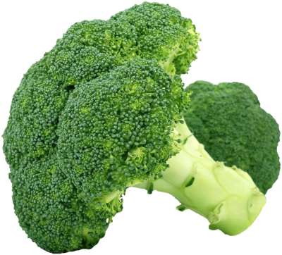
For example, 1 pound of steamed broccoli has only 99
calories and 14 grams of protein and only 9 grams of carbs, so
you can eat as much as you want to.
Some of the top vegetables to include in your diet are:
Spinach, Lettuce, Kale, Collard greens, Broccoli,
Cabbage, Peppers, Mushrooms, Onions,
Cauliflower, Brussels sprouts, Celery, Cucumber,
Asparagus, Artichokes, Tomatoes.
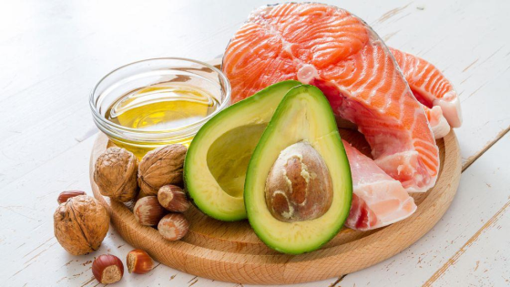
The Truth About Fats and How to Eat Them to Lose Weight
Many people often fear eating fat because they think if they eat fat, it will automatically turn into fat, but this is not true.
In fact, diets with moderate amounts of fat often produce
better results than those with no fat. Why?
First and foremost, fat will help to boost your overall level of
satiety. Basically, it helps ensure that you are not going to be
hungry shortly after eating a meal.
While protein slows down digestion considerably, fat slows it
down even further, and eating enough of the right fats is key
to easy long term weight loss.
Fat also, has no influence on blood glucose levels, so you
don’t have to worry about it releasing any insulin either.
But since a gram of fat has 9 calories, you must keep track of
how much fat you eat if you want fast results!
When it comes to choosing fat, you want to focus on eating
unsaturated sources along with foods that are rich in omega
fats.
Saturated fats which is mostly found in animal products,
should make up no more than 10% of your total calorie intake
and trans fats, which are found in processed foods and are a
man-made type of fat are to be avoided at all costs.
If you see the term ‘partially hydrogenated vegetable oil’ on
a label, you know it contains trains fats, so stay away from it.
Good fats are the following:
Avocado oil, Extra virgin Olive oil, Coconut oil,
Nuts and nut butter, Seeds, Avocados and Fatty
Varieties of fish
Before we finish the fats chapter, there is one type of fat that
has been proven to help dramatically in weight loss and even
though it is a saturated fat, it will help you. And I am talking
about coconut oil.
The first time people have realized coconut oil has fat loss
properties was around 1920. Some Australian farmers decided
to fatten their sheep with coconuts, which they had too
much at their farm, however they were stunned to see that all
their sheep became leaner after just a few weeks of eating
coconuts daily.
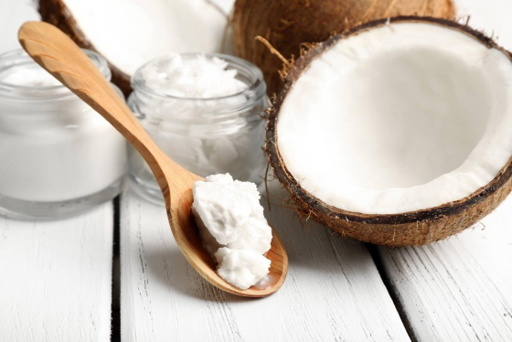
If you search the internet there will be thousands of
testimonials from people who have lost weight by consuming
coconut oil daily. It also reduces cholesterol, visceral fat,
blood sugar, it increases your metabolism with 5-10% and
helps prevent cancer, heart problems and acts as a natural
antibiotic.
So, How much coconut oil should you consume daily?
My tests were with 20-30 ml per day and has given wonderful
results for many women.
My recommendation is to use only coconut oil for cooking
and to start by taking 2 tea spoons per day, because each
body will respond differently. Also, be sure to only buy virgin &
organic coconut oil!
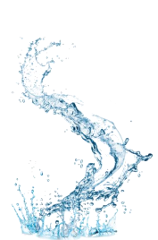
WATER AND HYDRATION TO
LOSE WEIGHT FASTER
Water is essential to our body’s general health and it is truly
essential for weight loss, not only for cleansing your body, but
also for keeping your metabolism fast.
Even slight amounts of dehydration can have a very
negative influence on both your energy level as well as your
total calorie burn.
A lot of people confuse thirst with hunger, so from now on I
have a recommendation for you. Each time you will feel
hungry, drink a big glass of water, and only eat if after 10
minutes you will still be hungry.
When it comes to how much water to drink, my
recommendation is to go for 3 liters per day, even more if
you can, and since most people simply forget to drink water.
Have a bottle of water with you all the time and set your
alarm so that it beeps every 30 minutes, reminding you to drink water.
YOUR DIET FORMULA FOR THE
NEXT 60 DAYS
Now, let’s look at THE FORMULA to structure your diet so that
you can lose over 20 pounds in the next 30 days.
To calculate your fat loss calorie needs, multiply your weight
in pounds with 9, however do not go under 1200 calories per
day. So, if you weigh 140 pounds, you should consume 1260
calories in a day.
The Morning Fat Melter 2 months meal plan, which you’ll find
on the dvd version for PC, is set for 1300 calories per day:
45% from proteins - 146 grams of protein, the equivalent of 585 calories
35% from carbohydrates - 113 grams of carbohydrates, the equivalent of 455 calories, and
20% from fat - 29 grams of fat, the equivalent of 260 calories.
All you have to do is weigh everything and prepare your
meals and you’ll ensure that your body is primed for fat
burning during most hours of the day, even while sleeping
during the night.
THE CHEAT DAY
Every 7 days, in order to keep you metabolism fast, you must
double your carbs, this meaning that every 7 days you’ll
consume MORE carbs. It is the day you can indulge yourself
and the foods you love the most, BUT TRY TO FOLLOW THE
PLAN FROM THE 60 DAYS MEAL PLAN!
And even though you might think that this is crazy, after years
of experimenting and seeing what works in weight loss, I
found that having a cheat day, every 7 days, will keep your
metabolism fast and your Leptin levels high.
So below, I will share a perfect scenario for you – This is how
your next 30 days should look like!
You wake up filled with energy, you drink a big glass of
lemon water and a cup of coffee with low fat milk (if you are
a coffee drinker).
You feel great and then, you do an easy Morning Fat Melter workout.
After the morning workout you drink a high protein shake
and take a shower. You already feel how all your clothes fit
you better.
Then you start your day and eat 5 more meals according to
the Morning Fat Melter meal plan. Your last meal is around 7-
8 pm and it is low on carbs, and all night long, your body will
use your fat deposits for fuel.
And since the meal plan I created for you will keep you
blood sugar in the “fat loss zone”, your body will be burning
fat up to 20 hours per day.
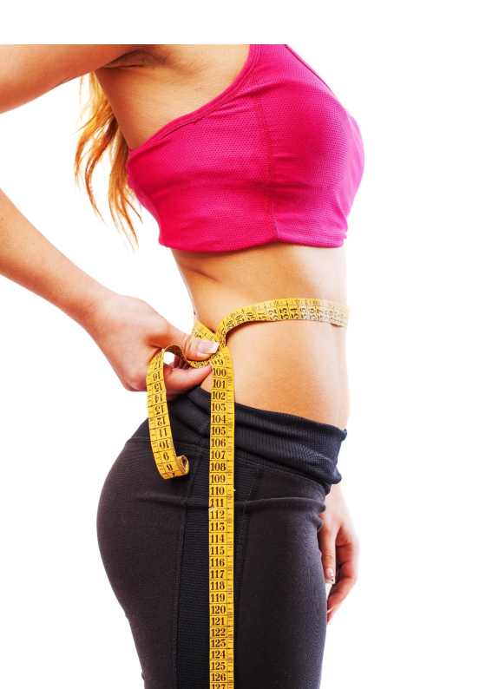
Basically, that’s all you have to do. Follow the meal plan precisely, do the morning workouts with me each morning, drink 3 liters of water per day and sleep 7-8 hours per night.
You’ll lose over 22 pounds in the next 30 days! Are you
ready?
I want to hear a big yes from you!
NOW SCHROLL BELOW TO GET STARTED RIGHT NOW!!!
NOW IT IS TIME TO REACH YOUR IDEAL WEIGHT!
Start The Morning Fat Melter program RIGHT NOW!
Click The Button Below NOW To Get 60% OFF!
You will lose over 20 pounds every month until
you reach your ideal weight, especially if you
add the 4 secret herbs and nutrients to your
meals!

