Please follow the steps which can lead user to use DDNS to configure ipsec vpn connection.
- Go to https://www.noip.com/
Sign up
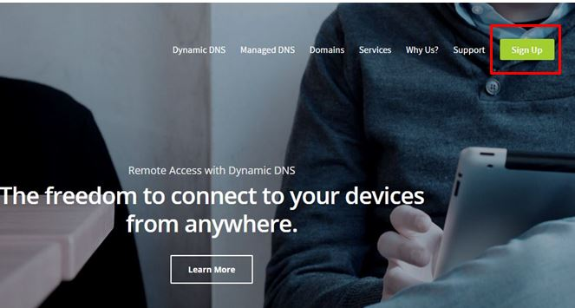
- Create new account
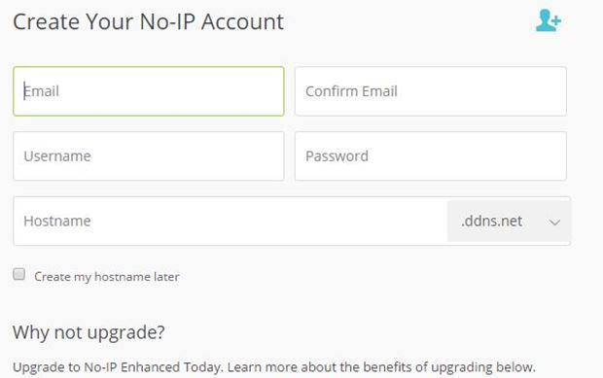
- Choose Free sign up
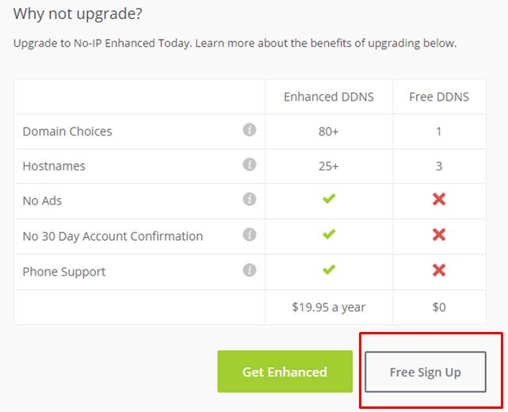
- Go back to your Email inbox to activate

5. s5553897.ddns.net is your one of domain
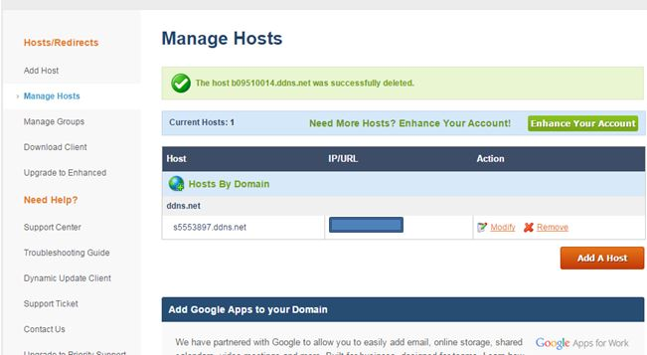
6. Press Add a host to create another one
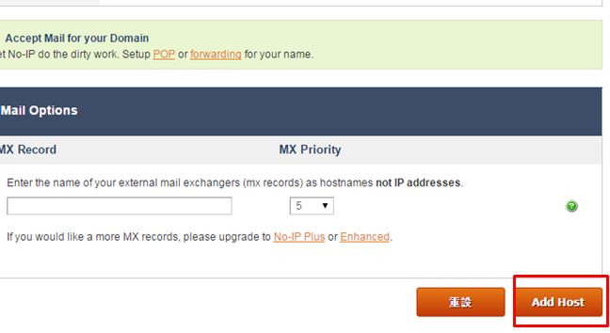
7. Added b09510014.ddns.net
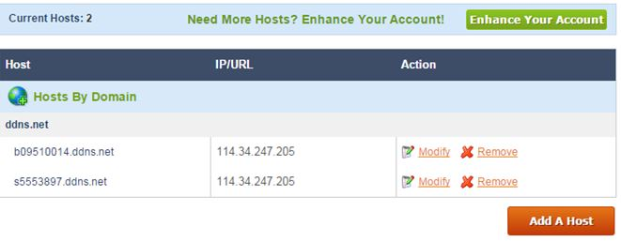
8. Go to Configuration>Network>DDNS>Create the profile for s5553897.ddns.net
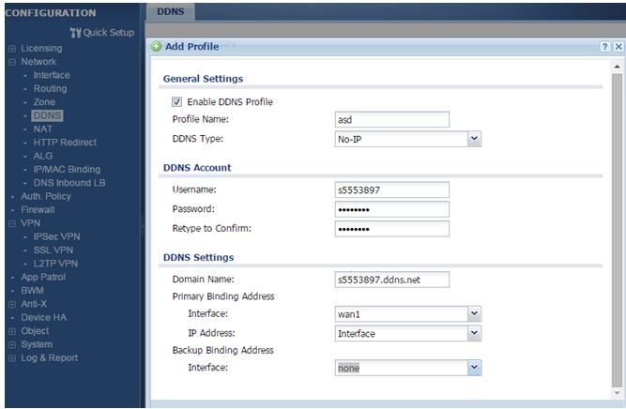
And also create the profile for b09510014.ddns.net
9. Go to VPN Gateway >Set 0.0.0.0 on Domain Name
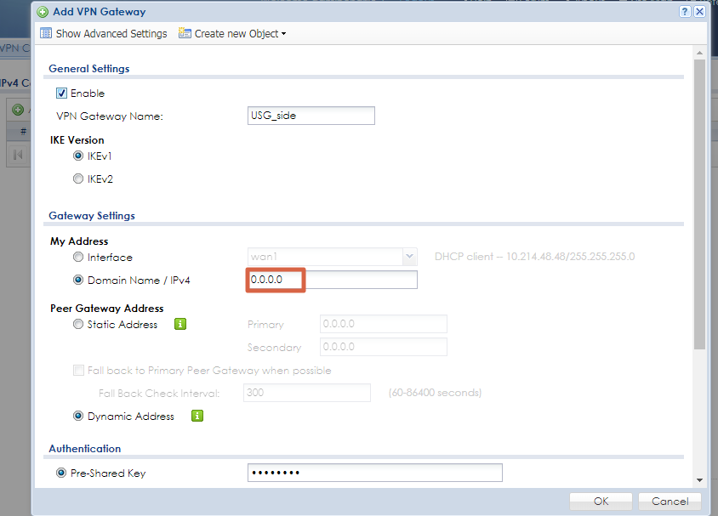
On Peer device, please follow the configuration as below
Here is example:
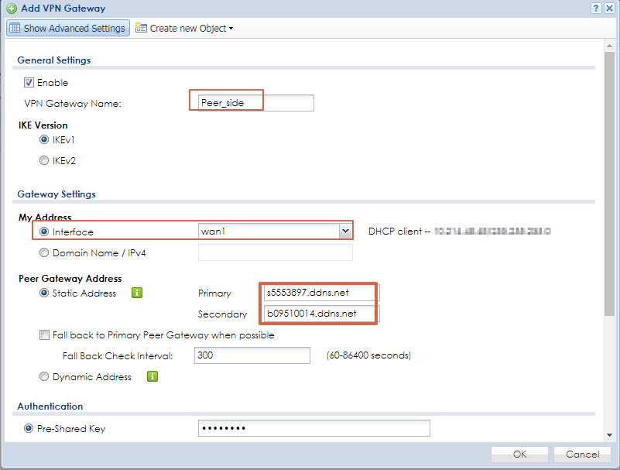
Note: The VPN session need to be initiated from Peer side.

