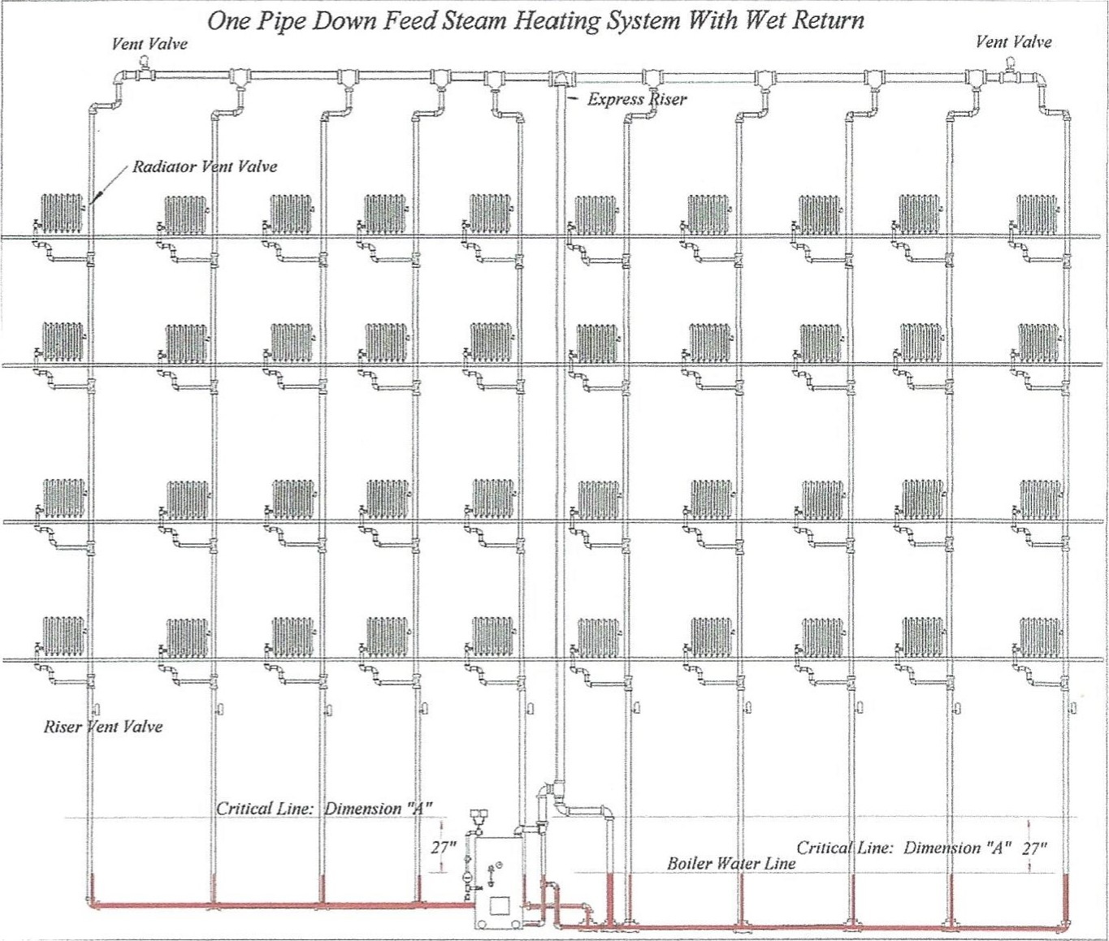
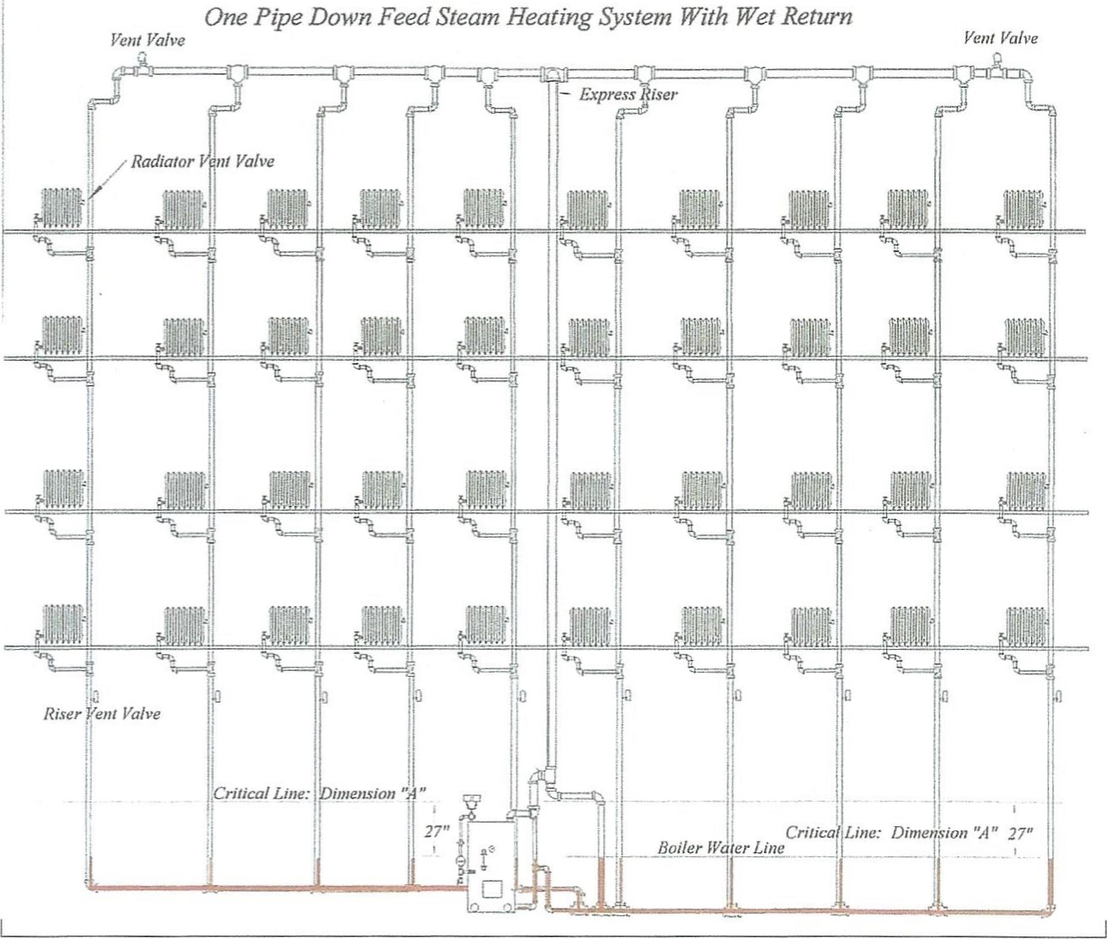
A one-pipe down feed system is a marvel of thought and engineering. At first glance, we see an up-feed steam riser and quite a bit of expensive extra piping. To understand the benefits of this design and thought, we need to remember that boilers can be put in any location in a building. Assume the boiler was put in a corner of the buildi1V. The main steam supply pipe would start at the boiler room and could end at the opposite corner of the building.
Apply this thought: A building is 400 feet long and about 100 feet wide. Think about the dimensions, pressure drop, system differentials, air removal, and uniform steam circulation. Think about overcoming the time differentials when heating an entire building. After some thought, we realize that two steam mains need to be run. Both steam mains would be about 400 feet long. This is not a problem, but pipe slopes may affect the way the basement spaces are used.
Think about what 400 feet of steam main translate to in vertical drops, especially the vertical drop at Dimension "A." Most steam mains are pitched at 1 inch for 10 feet of horizontal run. A 400-foot steam main starting at the boiler room will have a 40-inch drop or fall. Many buildings did not have basements with ceilings high enough to fit a 40-inch drop of pipe. Additionally, doors, passageways, and windows could affect the installation and placement of the steam main and main return. What is very important to understand about a 40-inch pipe drop is the impact the height of the end of the steam main has on Dimension "A" and the boiler.

Imagine a basement with an 8-foot ceiling. A 4-inch steam main starts in the boiler room about I-foot lower than the ceiling. The bottom of the 4-inch steam main is about 67 inches above the basement floor. Because the pitch of the steam main is 1 inch in 10 feet, the drop at the end of the 400-foot steam mains is 40 inches. A drop in height of 40 inches lowers the bottom of the steam main to 27 inches above the floor.
Remember Dimension "A." Many coal boilers had standing boiler waterlines from 48 inches to 72 inches above the basement floor. In this example, we have a serious problem. The steam main is at least 13 inches below the boiler water level. To solve this problem, the boiler was installed in a pit or a subbasement.
See the drawing on page 31. Look at the base of each steam riser. Check the height difference between the "A" dimension and the vent valves on each steam riser. The designer placed the vent valves near the ceiling, and this permitted the boiler to be installed on the basement floor and not in a pit or subbasement.
Look at the down feed system (an actual steam system found in a rectory in New Rochelle, New York). Follow the steam main from the boiler to the overhead steam main. See where the steam main splits? The split is at the exact center of the piping system. Both steam mains were designed with equal heating loads and pressure drops. What this means is that the system designer sized and chose the locations to install the boiler, the steam, and return piping, and, by doing so, assured that steam will enter all the radiators at about the same time.
Both steam mains are equipped with vent valves and each steam riser has a vent valve installed in the basement. Vent valves installed on down feed risers must be placed as high as possible above dimension "A." The designers of down feed systems understood steam circulation in piping systems. They improved steam circulation by creatively venting air from the steam system.
Condensate removal or controlling the flow of condensate water is dealt with simply. In many down feed systems, the steam main from the boiler to the express riser is counter-flow. Small amounts of condensate are generated by the short run of piping and drains into the boiler via the boiler equalizer. The waters of condensation in the express riser drain into the wet return via the drip at the base of the express riser. Because water is removed quickly, the steam used for heating is free of excess water.
Once steam reaches the upper steam mains, steam, and condensate water flow in the same direction. The beauty of a down feed steam riser is that the riser is not subject to a counterflow condition. Steam, and the waters of condensate, flows in one direction, down the riser to the wet return.
In twenty years of problem solving, I serviced six down feed systems. Each system became problematic after a new boiler was installed or a modification was done to the building heating system. To cure the problems, a rework of some piping of the modifications was necessary. Pipe changes that occurred due to the new boiler installations and modifications to heat to the new office spaces and added rooms became necessary. The rework was usually replacing an undersized steam supply pipe or installing drips to remove condensate that collected in some steam supply pipes.
The buildings had problems due to boiler change outs. See the drawings on pages 34 and 35. These two buildings were not so easy to fix. Dimension "A" was drastically altered and master steam traps and condensate pumps were installed to separate the steam piping and return piping from the boiler.
Look at the down feed system again. No mechanical devices other than vent valves were used. When Dimension ^{C}A" is compromised, sometimes, the only economical way to fix the problem is by installing steam traps and condensate pumps. Installing steam traps and condensate pumps to remove condensate water and pump the condensate water into a boiler can create boiler cycling problems. Cycling problems cause boiler flooding, overflowing of the condensate receiver, or combination of both conditions. The remedy for those problems can cause a serious financial dilemma.
Look at the down feed riser and the wet return. The smallest condensate drain at the base of these risers is IV4-inch pipe. The wet return increased in size, both wet returns met near the Hartford Loop, and connected to a 2¹/2-inch pipe.
When a low-profile steam boiler is installed in place of a standard boiler, one or both wet returns could become dry, and result in banging. Steam will flow back and forth in the dry return and can flow up the down feed steam risers.
Remember the pressure drop: In a down feed system, when the wet returns become dry, steam will flow to the path of least resistance. On the left side of the drawing, the wet return is a bit higher than the wet return on the right side of the building. When this return becomes dry, steam will flow down the first steam riser take-off. Looking at the down feed steam main, we see a long run of pipe to the last riser. The pipe and fittings on the steam main offer resistance to the flow of steam. Therefore, the steam pressure at the end of the steam main is lower.
When steam flows down riser one, the steam pressure is slightly higher than the steam pressure in risers 2, 3, and 4. This results in steam flowing into the dry return. That steam will flow to risers 2, 3, and 4. Steam will always flow toward the point of lower pressure. The vent valve at each radiator and the vents at the end of the steam main are responsible for creating the zones of least pressure. Air is vented from the system and steam flows toward the vent valves.
When the steam piping and radiators are heated, condensate is formed. Cooler, denser condensate water collects in the wet return that became dry. Steam moving in the dry return toward risers 2, 3, and 4 (a counterflow condition caused by the loss of the water seal) meets the condensate water returning from those down feed steam supply risers, and hammering occurs. Banging in the dry return continues until enough condensate water collects and the water seal is restored. In some systems, the return may stay dry and banging will persist throughout the boiler's duty cycle. When this happens, this problem can be resolved and several of the fixes are shown in the following pages.
When a new boiler is installed in this building, the boiler will most probably be a low-profile boiler. The standing waterline of the new boilers may be as low as 20 inches above the floor. The new lower boiler water level will cause the wet return at the left side of the drawing to go dry. A preventive alteration to the near boiler piping will allow a low-profile boiler to work in this system. methods can be used, depending on the size and pressure drop of the steam system.
The first alteration is to install a false waterline at the wet return piping. Another alternate is quite expensive. It uses a condensate pump/receiver and master steam traps. Both methods raise the water level in the wet return piping. By raising the water level in the wet return, all riser Ts are well below the waterline and steam cannot enter the wet return piping.
Since we have established a water seal (a nonmechanical steam trap), steam is isolated from the return side of each riser. Water seals hold steam in the steam side of the system and prevent the steam from crossing over into the return side of the system, and cause the water and steam to flow in one direction now. What is important to understand is that the entire piping system is pressure balanced and the entire system's equilibrium is restored. Sketches of both techniques are shown on page 34 and 35.

Steam System with False Waterline
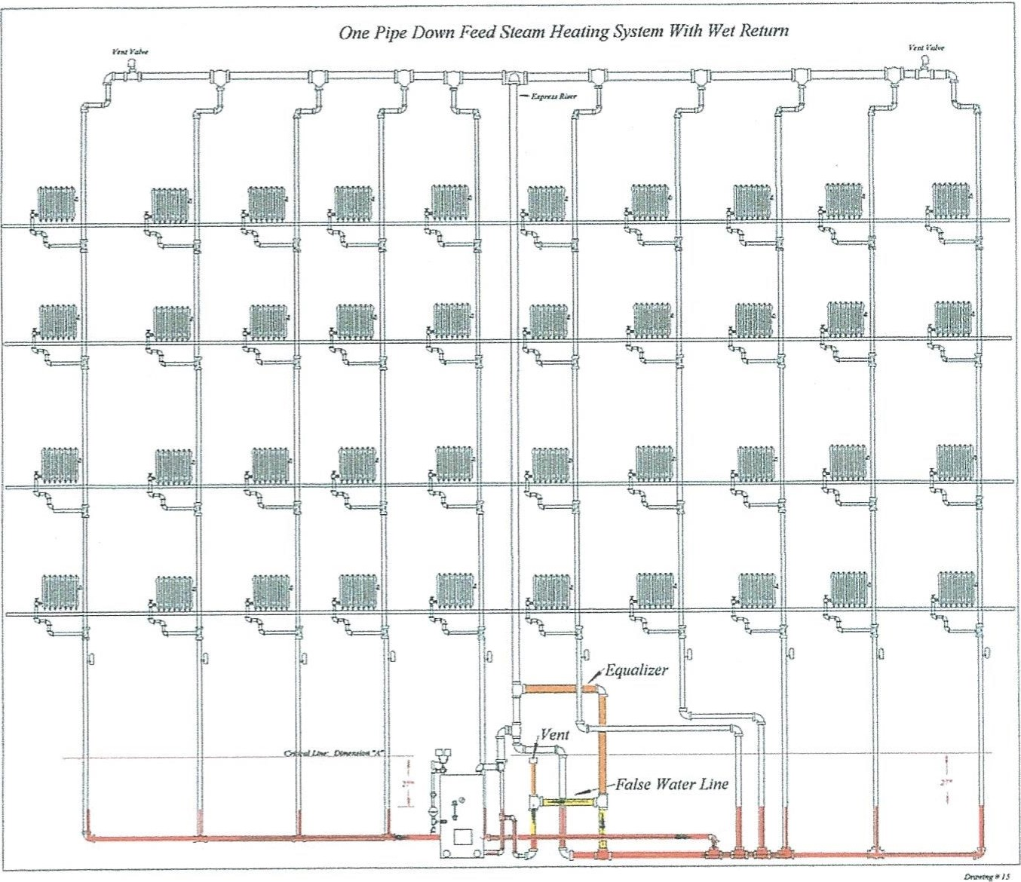
Shown in redSystem condensate or retained water
Shown in yellowFalse waterline
Shown in orangeEqualizer pipe added to the express riser
Compare this drawing with the next modification shown below.
False waterlines raise the water level in the return piping. This results in all the Ts in the wet return being covered with at least 2 feet of water. The water seal prevents the wet return from becoming a dry return. Steam cannot enter the return piping and cause banging or travel up the risers. Setting the height of the water level is simple. The water level height is normally the original boiler waterline.

Steam System with Master Steam Traps and Condensate Pump
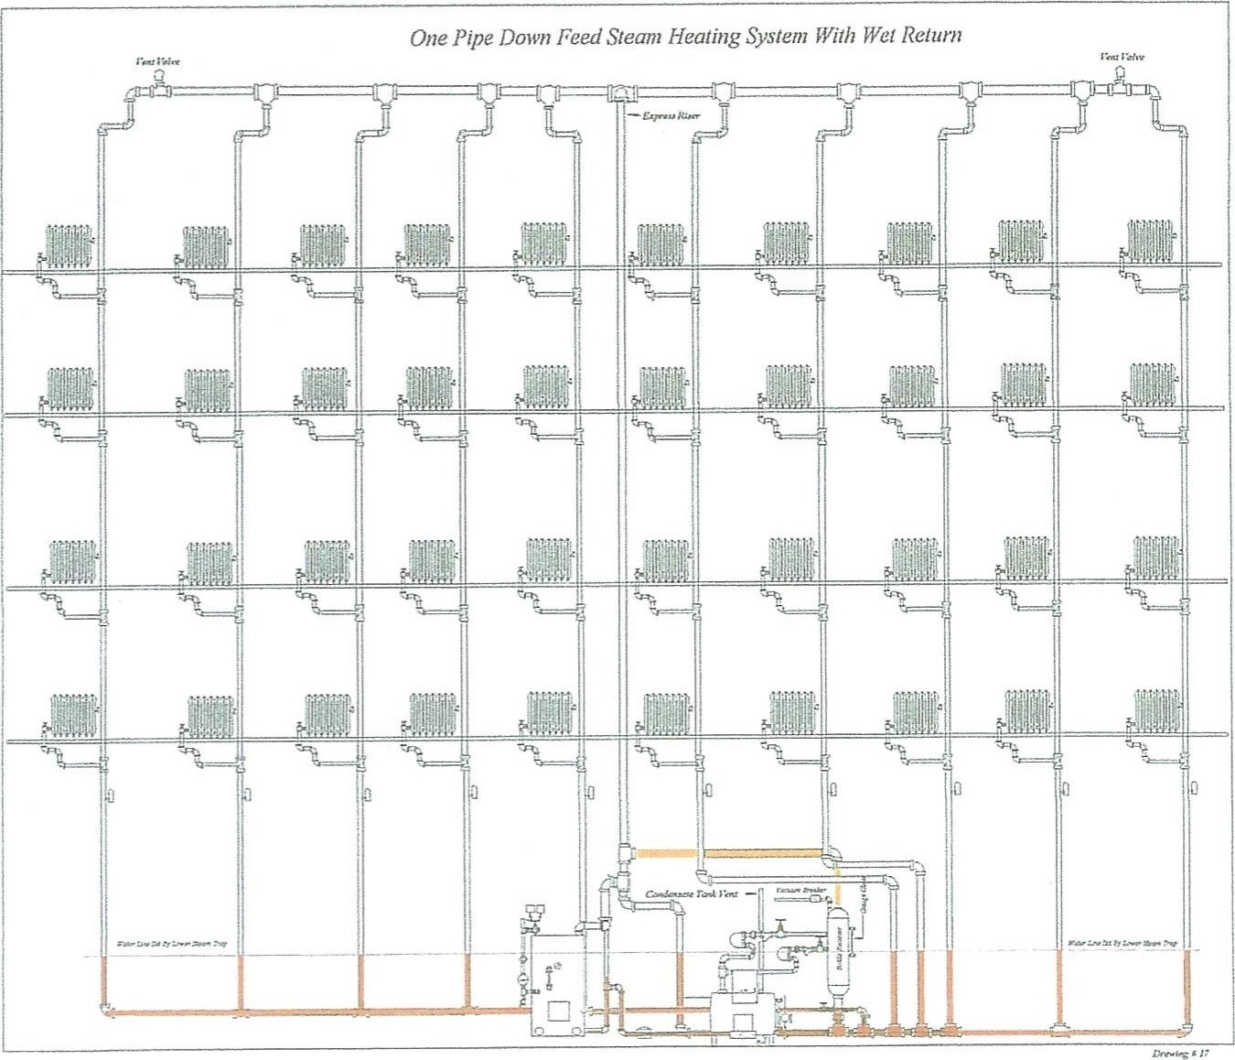
Shown in red | Retained condensate
Shown in yellow | Piping to steam traps
Shown in red | Equalizing pipe for the condensate accumulator
Installing a master steam trap in a steam system requires a great deal of care! Selecting a steam trap by its nominal pipe size or gut feeling can lead to a variety of problems. Steam traps discharge pounds of condensate per hour based on Pressure differential. The pressure differential is the difference between the inlet pressure into the steam trap and the back pressure of the piping or vessel to which the condensate water is discharged. Here, the condensate receiver is open to the atmosphere and no measurable back pressure exists. The inlet pressure to the steam trap is 2 psi and the discharge pressure is 0, so the differential pressure is 2 psi. Before selecting the trap, we need to know, with certainty, how much condensate is generated by the entire steam heating system.
In the drawing, one-pipe down feed system is a building with 40 radiators. Each radiator is rated at 80 EDR or 80 square feet of steam. This heating system has a total connected heating load (radiators are the connected loads) of 3,200 EDR; 3 3200 EDR times 240 BTUH (240 BTUs equals 1 EDR) equals 768,000 BTUH.
To calculate pounds of steam per hour, we divide 3,200 EDR by 4; 4 EDR equals 1 pound of steam or evaporated water; 1 pound of steam (evaporated water) equals 4 square feet of steam or 960 BTUH. Divide 768,000 BTUs by 960 BTUs, both formulas show 800 pounds of water are steamed off during each full hour of boiler operation. Additionally, the piping system will remove latent heat from the steam and form condensate.
This steam system has a very large and extensive amount of piping. The designer used 1.50 for the pickup factors rather than 1.35 that, in the early days of steam heating, was typical.
Radiators (connected heating loads) 768,000 BTUH
Piping heat losses are 384,000 BTUH
Total BTUs needed for heating is 1,152,000 BTUH
We know two things about this steam heating system!
- 384,000 BTUH is needed to heat all the piping in the building. That is 400 pounds of evaporated water generated each hour before steam enters all the radiators.
- 768,000 BTUH of steam is needed to fill all the radiators with steam to heat the building on the coldest day of the year. That will generate 800 pounds of condensate each hour of boiler operation.
Calculating condensate loads is a problem. Heat supplied to a building is variable. Properly-sized boilers rarely run for a full hour. In many buildings, a boiler will run between 15 and 30 minutes to establish steam circulation. Additional time is needed to heat all the rooms to the set temperature. Weather conditions vary; therefore, the steam supply varies when the building needs heat.
'CA boiler always chases the temperature controller.
How do we size a master steam trap? Look at the trap tables. Here we see varying steam trap a discharge capacities. The discharge rates increase as the inlet pressure to the trap increases. Look at the table carefully. Example: A ³/4-inch steam trap's discharge capacity starts at ¹/4 of a pound and goes through 5 psi. The steam trap's capacity to discharge water is 279 pounds to 785 pounds of condensate per hour.
Each size trap has variable load capacity. Variable loads occur because steam systems' operating pressure range from 0 psig to the system set point.

Example:
1"2" Trap size
279
279 600 1,100 2,300 Pounds per hour condensate
369 369
770 1,700 2,800
- 489 489 980 2,400 3,600
- 650 650 1,240 3,300 4,650
5 785 785 1,640 5,000 6,900
This steam heating system generates a total 1,200 pounds of condensate per hour. At every boiler duty cycle, 400 pounds of steam per hour is needed to heat the piping and as little as 200 pounds steam per hour to heat the rooms. Since 600 pounds of steam is the lowest heating load, we can use the 600 pounds of condensate water as the baseline. The sizing chart shows a IV4-inch steam trap at ¹/4 psi; pressure differential will drain 600 pounds of water per hour.
We know the system operating pressure is set at 2 psig, fuel burner off, and at 1 psig, the fuel burner on, or the burner modulates between 1 and 2 psi steam pressures where the boiler constantly produces steam during the heating cycle. Based on the settings, we can calculate an average pressure of 1 ¹/2 psi. Look at the table again! At 2 psi, the 1 ¹/4-inch steam trap's discharge capacity increased to 1,240 pounds of condensate water per hour; 1 ¹/4-inch steam trap will drain all the condensate the system produces. Therefore, the steam trap selection process starts with a 1 ¹/4-inch steam trap.
In my travels, in some buildings I serviced, I found a 2-inch float and thermostatic master steam trap. Look at the chart again. A 2-inch steam trap at a ¹/4 psi inlet pressure will discharge 2,300 pounds of condensate water per hour, and at 2 psi, the trap will discharge 4,650 pounds of condensate per hour. A 2-inch steam trap in all pressure ranges has a discharge capacity 3.5 times greater than the actual condensate load. Proper use of steam traps, depending on the application, requires a safety factor of 2 to 3 times the actual condensate load. The safety factor is needed for the initial start-up. An initial start-up is when the cold piping of the steam system is heated. Cold steam system start-ups cause a great deal of condensate to form in a short time. A steam trap must drain the water produced by the start-up loads quickly, or piping system flooding will occur. Be mindful of this fact: "system flooding causes poor steam circulation and banging will happen." Many steam heating systems operate on and off. These steam heating systems have multiple start-ups each day. Proper air and condensate removal will prevent many problems from happening.
What needs to be understood is that in all steam heating systems, master traps, in reality, are a float operated, water-regulating valve. The trap is not used as a steam trap per se. Trap sizing and safety factors apply in this installation.
Look at the piping system closely:
Note the height of the pipe from the false waterline to the vent valves. This basement has 8-foot ceilings and the riser vent valves are installed about 7 feet off the floor.
The lower master trap is about 48 inches above the floor Look at the return portion of a steam riser. Each riser can hold a head of water almost 3 feet above the lower steam trap (the standing waterline plus the height of the piping to the vent valve). A 3-foot static head of water adds 1.3 psi to the inlet pressure of the steam trap. That additional static pressure increases the discharge capacity of the 1 ¹/4-inch steam trap to about 1,400 pounds of condensate per hour.
Steam trap manufactures recommend adding additional capacity to steam traps by using a safety factor. In this application (a master steam trap), the steam trap may never see steam (see drawing on page 39). The steam trap is used as a water-regulating valve. Because all the condensate from the heating system passes through the master steam trap, we need some redundancy. Install another steam trap of equal size; that steam trap is put in place in the event the primary steam trap fails. The second steam trap is the safety factor, and that is a factor of 2.
Additionally, at lower operating pressures, the second steam trap at a higher elevation adds drainage capacity to the system, and it will prevent the system from flooding during a cold start.
Remember, when altering steam systems, follow the rules. Make sure condensate water will flow by gravity to the designated collection point and system air is vented. Keep the steam side of the system separated from the return side of the system with water seals or steam traps. Remember, solving problems in steam heating systems is an art. Occasionally, we get lucky and make a 100% fix. Additionally, a foolproof fix does not exist, especially where mechanical equipment is installed in an old system where no mechanical equipment was installed before.
What must be remembered is that steam pressure is present during the heating cycle. The steam trap is connected to a condensate receiver that is open to the atmosphere. During the heating cycle, a pressure differential is always present at the steam trap or traps.
During the heating cycle, water is discharged continuously, and under some conditions, the wet return can go dry. Because the steam traps are sized close to the actual condensate load, condensate water is retained longer in the wet return piping. If banging occurs, it will happen near or at the end of the heating cycle.
When oversized steam traps are used, greater amounts of condensate water are pushed out of the wet return quicker and banging can occur sooner.
The method of condensate removal shown was installed by the boiler installing contractor. The contractor's error was installing 2-two-inch steam traps. Correcting poor steam circulation and eliminating the banging in this system was merely the resizing of the existing master traps.
My approach to fix the problem was based on economics. Economics does not mean remove the problem cheaply; it means fixing the problem so this problem will not recur. I knew the 2-inch steam traps created the problem and I had to prove to the customer that the traps were oversized. I calculated the condensate load, selected the steam traps, removed the 2-inch steam traps, and installed two 1 ¹/4inch traps. Replacing the steam traps stopped the banging, improved the steam circulation, and that was the most economical approach to correcting the problem.
Another solution to correcting this problem is quite costly and should be done during a boiler change out. This method involves building a receiver from a 10-inch pipe and installing a condensate pump or boiler feed pump. Condensate water enters the bottom of the receiver and an equalizer is piped from the steam main into the top of the receiver. The equalizer stabilizes system pressure and keeps the return side of the system in balance and the steam system's differential pressure is maintained. Additionally, a vacuum breaker needs to be installed at the top of the receiver, and the vacuum breaker prevents a vacuum from forming in the bottle receiver.

Modified Down Feed System
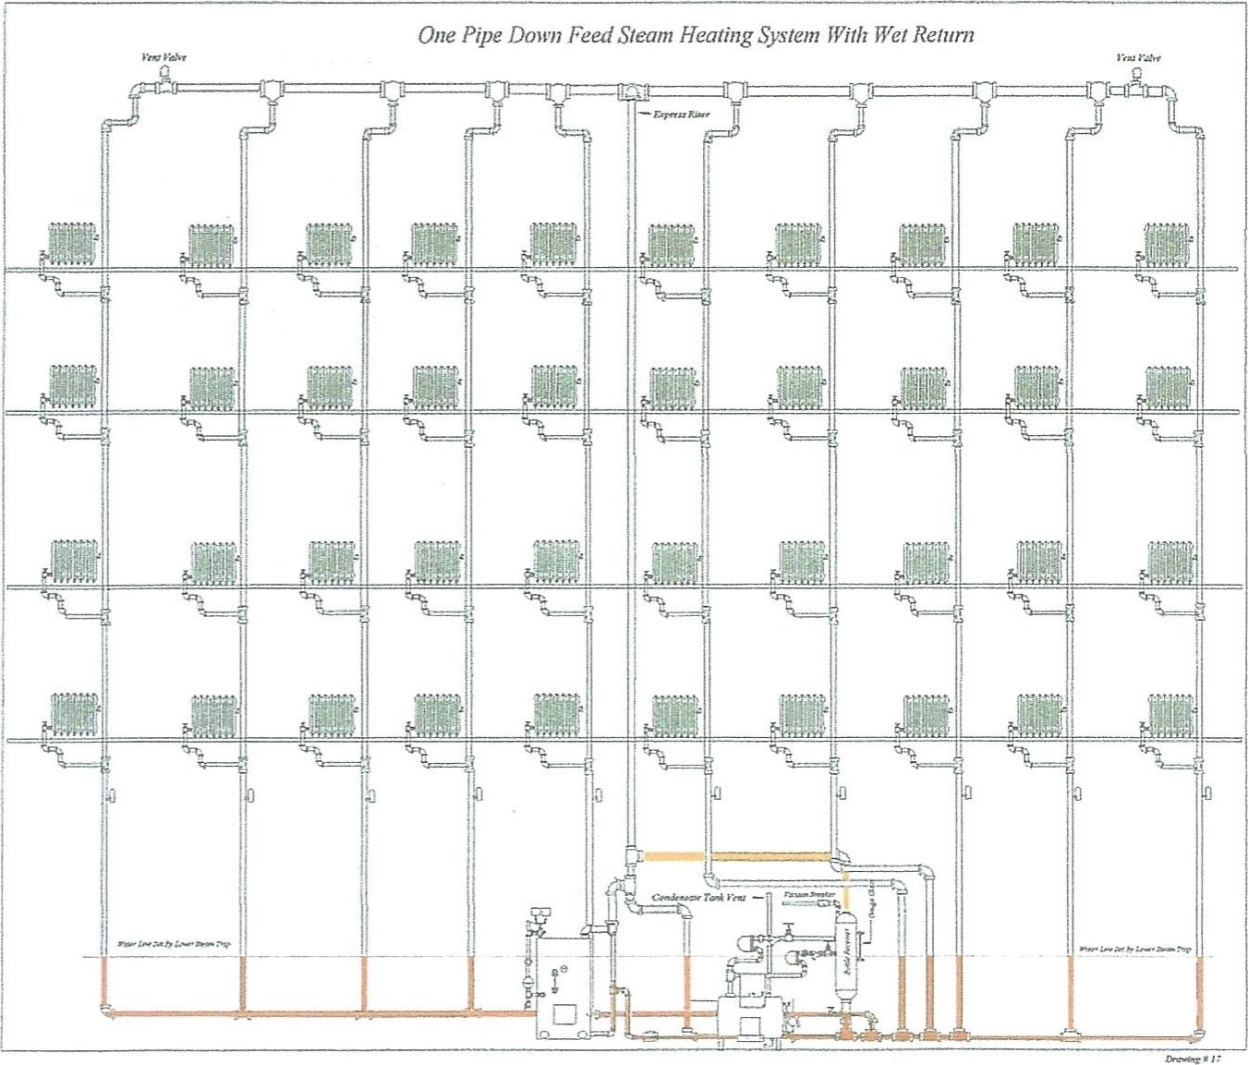
Note: All modifications were done at the base of the express riser and the return side of the system. No vent valves were removed. The only steam traps installed were at the bottle receiver.
Red: represents the water level set in the return piping. This water level is the original water level of the original coal boiler.
Orange: represents the steam equalizing pipe. The equalizer is needed to keep the system pressure in balance.
In all methods of condensate removal, gravity, static head, and steam pressure force the condensate water in and out of the steam traps. Here, the installation of a bottle receiver sets the false waterline.
Additionally, the bottle receiver simulates a boiler and keeps the steam piping and wet returns in a state of equilibrium.
How the bottle receiver works: The bottle receiver equipped with steam traps separates the boiler and steam system from the condensate receiver and allows water to collect in the wet return. Condensate water from the wet return enters the bottle receiver from the bottom tapping. This water will rise to the side outlet of the receiver and drain out of the steam traps to the condensate pumps. Steam pressure enters the bottle at the pipe tap on top of the bottle via the equalizer piping. That steam pressure and the static head of water in the bottle emulate the conditions present in the heating system with the original boiler.
Steam pressure in the bottle is subtractive from the steam pressure and static head of water that collects in the vertical drop at the end of the steam main. The bottle receiver and steam traps do three things: A bottle receiver maintains the "A" dimension at the original height, isolates the return sides of the system from the condensate pump set, and emulates the original gravity return steam system when the wet return was connected to the coal boiler.
This steam system was designed with a ¹/2-pound pressure differential. Therefore, the steam pressure at the end of steam piping system is a ¹/2 pound less than the pressure in the return piping. Since the wet return is under a greater pressure (steam pressure in the boiler) than the end of the steam main, water will back up about 14 inches above the standing waterline at each riser before equilibrium occurs. Because the two steam traps start discharging water at ¹/4 psig, the water level can rise another 7 inches.
Condensate water in the wet return and at the base of the steam risers can rise 21 inches before the steam traps begin to discharge water. This small, innocuous piece of information does not seem relevant. Nevertheless, let us look at where the vent valves at the base of the steam risers are. Remember, this basement has an 8-foot ceiling, the highest steam trap is about 4 feet off the floor, and each vent valve is about 1 foot below the ceiling.
The water level in the wet return at atmospheric pressure is 4 feet above the basement floor. Condensate will stack up in the vertical piping an additional 21 inches and the vent valves are 84 inches above the floor. The maximum height the water column will reach is 67 inches above the floor and the clearance between the vent valves and the highest waterline is 17 inches. Remember, condensate water must not enter the vent valves.
After checking the height of the vent valves and learning that water cannot reach the vent valves, I decided that other piping alterations would not be needed.
When problem solving, repairing, or installing piping and equipment in an old steam system, we need to know what the original designer's operating parameters were. We need to check and test the operation of the system before planning the corrective work and double check our plan.
Sizing and selecting the steam trap: Recheck condensate discharge capacity and determine the safety factor.
A 1 ^{I}A-inch steam trap, at ¹/4 psi differential pressure, will discharge 600 pounds of water per hour. Both traps, together, discharge 1,200 pounds of condensate water per hour, and as the steam pressure increases, the steam trap will discharge greater amounts of water. When the steam system's pressure reaches 2 psi, each steam trap will discharge 1,240 pounds of water per hour. Both steam traps will discharge 2,480 pounds of water per hour. Because the steam system generates 1,200 pounds of steam per hour, our safety factor is slightly greater than 2.
Remember the problem occurred because two 2-inch master steam traps were installed on the return side of the system. Look at the capacities of those steam traps.
A 2-inch steam trap, at ¹/4 psi pressure differential, can discharge 2,300 pounds of water, and at a differential of 2 psi, the trap will discharge 4,650 pounds of water.
A 1 ¹/4-inch steam trap, at ¹/4 psi differential pressure, will discharge 600 pounds of water per hour, and at 2 psi differential in pressure, will discharge 1,240 pounds of condensate each hour.
A 2-inch steam trap can drain nearly four times the water n 1 ¹/4-inch trap can drain.
Think about how a steam boiler works in a gravity steam heating system. Burners or heating elements in a boiler are brought online by temperature controllers. Other controls regulate fuel consumption, control steam pressure, and control the hot water temperatures. The temperature control also shuts down the burner on the boiler.
A boiler contributes BTUs into a heating system by the hour. During a boiler's initial start-up, the boiler operates in a full-fire or high-fire mode. This causes a steam boiler to supply the maximum amount of steam it can produce until the building reaches a set pressure or temperature.
Once a boiler reaches its set point, the burner will shut down or the flame will cut back until the low-set point is reached. In on-and-off systems, when the burner shuts down, system steam pressure decreases until the low-pressure setting is reached. When a burner shuts down, the post-purge cycle clears the boiler's firebox of unburned fuel gas and products of combustion. When the pressure control calls the burner to come back online, the pre-purge cycle clears the boiler's firebox and flue passes of any remaining unburned fuel and products of combustion.
Post-purge and pre-purge cycles cool the boiler's internal water side metal because the ambient air in the basement, supplied by the burner fan, has a cooling effect in the boiler's combustion chamber and flue passes. That cooling effect can lower the steam pressure in the boiler to 0. Each time the burner comes online, it will produce steam and the steam will flow to the piping system.
Fuel burner cycling can create problems, because the amount condensate generated is far less than the discharge capacity of the mater steam trap. Each time a boiler produces steam, the steam trap can discharge more condensate than the boiler can produce. As a result, water stored in the wet return is pushed out of the piping system and the wet return becomes dry.
Steam trap ratings show pounds of water discharged by the hour. Steam condensate is produced and discharged from the steam trap by the minute, and that condensate water will flow to the vented condensate receiver.
When a master steam trap is installed on a wet return, it should be installed to create and maintain a false waterline. The false waterline will assure that all riser drip “T" connections in the wet return are underwater. Additionally, when a false waterline is used, be sure that changes to the piping do not negatively affect system air removal. Then condensate water is drained or forced out of the wet return too fast, the wet return will become dry; steam from the return risers will enter the wet return via the riser drip "T," and banging will occur.

In a properly-sized boiler, when the boiler's water is hot, the boiler can make steam and pressurize the steam piping system in 8 to 15 minutes. A boiler will run until the pressure control or temperature control is satisfied. Once steam circulation is established and depending on the outdoor temperature, a boiler can operate for 10 minutes to continuous operation. Steam pressure and condensate build in the steam and wet return piping. The float and thermostatic steam trap discharge the water to a vented condensate receiver. Each time a steam trap discharges water, the steam pressure drops off slightly and steams flows toward the steam trap. In effect, the operation of the steam trap created a zone of lower pressure at the terminus of the steam pipe served by the steam trap.
In gravity steam heating systems, float and thermostatic steam traps must be installed below the steam main. This placement of the steam trap allows the condensate to drain out of the steam main by gravity and keeps the steam main free of water. Look at how steam traps are sized. Note that the ratings start at a ¹/4 of a pound differential. This means a steam trap discharges almost no water until ¹/4 psig is reached. Under that condition, condensate retention in the steam main can occur. If a steam trap is installed, install it at least 7 inches below the bottom of the steam main. The trap needs a static head of 7 inches of water to be able to discharge condensate water at 0 steam pressure.
Condensate produced in a heating system under average boiler operation never reaches the maximum discharge rate of a steam trap. Because most steam traps discharge water faster than the system can produce condensate, we need to be very careful how we size the master steam trap. The safety factor in trap sizing can cause us as much a problem as under-sizing a steam trap.
In the example, piping modification, the two 1-inch steam traps worked well. The problem was solved, but I had reservations about how well the repair would work. The master steam trap had a safety factor of 2; if the second steam trap was installed to low, the wet return could become dry.
Look at the steam chart again. A 1-inch steam trap at ¹/4-pound differential pressure discharges 279 pounds of water and at 2 psi; it will discharge 650 pounds of water. Had I installed two I-inch steam traps, the discharge capacity would be less than the 600 pounds and 1,200 pounds of water. Due to the height of the vertical drip piping, additional water can be stored in each of the ten riser drips. The additional 37 inches of static head increases the discharge capacity of the steam traps and flooding of the steam main would be averted. Nevertheless, there would be no safety factor. I could have opted to install a third I-inch steam trap and would have had a 50% safety margin. The three I-inch steam traps were a fallback position if the two IL-inch steam traps would cause the wet return to go dry and not remove the banging problem.

Jacob (Jake) Myron

element, the element opens, water and system air are released, and more steam enters the radiator or piP1ng. Condensate water and air flow toward the boiler and air is released from a master vent valve equipped with an air check. An air check prevents air from entering the system via the vent valve.
Radiator vent valves equipped with air checks were installed in some one-pipe and two-pipe air vent systems. In a two-pipe gravity vacuum system, one master vent valve chamber and a large capacity vent valve with an air check released air from the system. The air check prevented air from reentering the heating system, and a vacuum developed as the steam condensed and the boiler and piping cooled.
Drawing # 27 shows a two-pipe down feed steam system. I believe this system is a hybrid of the one-pipe down feed steam system. When I use the term hybrid, I mean the piping system was modified from the original installation. I found this system in a building on Lafayette Street in downtown Manhattan. Originally, the building was a printing plant. Around 1920, the building was converted to office and storage spaces. About 1950, the building became a multiple dwelling, and in 1980, when the building became a condominium, the system was changed to a two-pipe steam system with steam traps.
Drawing # 27 shows how condensate, air removal, and the return of water to the boiler are handled. What is remarkable about this very large system is that no condensate receiver and pumps were needed to return water to the boiler. In this building, steam traps were installed on the radiators. Steam traps on the steam main were not needed because the express riser drip and steam and return riser drips were connected directly into a wet return.
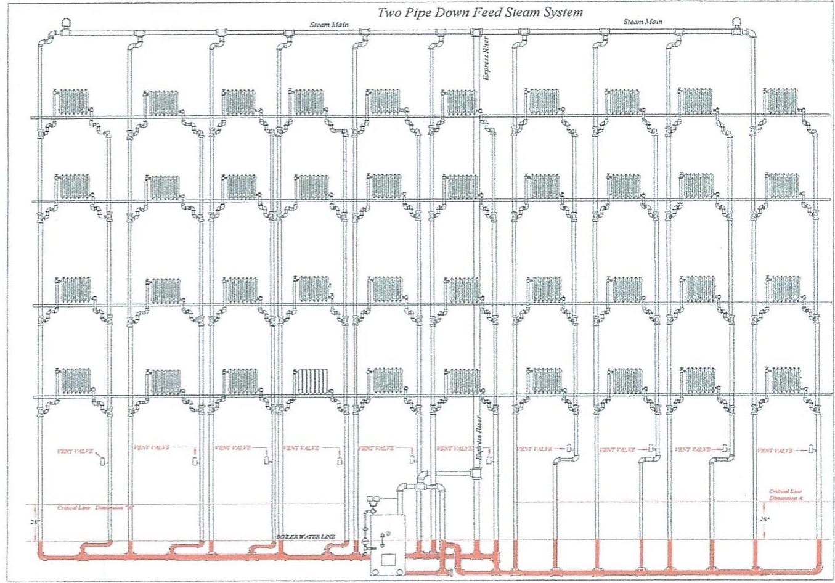
Drawing27

68
Steam

Air removal occurs via vent valves on the overhead steam mains and the base of each return riser. This building had a system pressure drop of about 3/8 of a pound. I was called to the building to solve two problems: find out why the vent valves failed several times in each heating season and resolve the no-heat and banging complaints on the lower floors at the left side of the building.
I found an obstruction in the wet return. Pipe scale and rust accumulated in the wet return piping. Accumulated mud created a dam in the piping and prevented the returning steam condensate water from returning to the boiler. The failure of the condensate to flow to the boiler caused the water level to rise in the vertical returns and the condensate backed into the radiators on the first and second floors. When the wet returns were cleaned and the vent valves on the return risers were replaced, water hammering ceased and heat was restored to the affected apartments. Additionally, after changing a defective steam gauge on the boiler, I found the system steam pressure was set at 7 psi with no differential. I replaced the pressure gauge and installed a Vaporstat , roughly calculated the pressure drop of the system and set the operating steam pressure at 1 psig with a 4-ounce differential. By setting system operating steam pressure at 1 psi, burner off, and 12 ounces (³/4 psi) burner on, the vent valves at the return risers stopped hissing and spitting water.
After working with thumb rules for many years, I learned that the operating steam pressure in a steam heating system is determined by the pressure drop of the piping system. The pressure drop multiplied by two is about the maximum operating pressure of a steam heating system. This system had 3/8 of a pound pressure drop.
Multiply the pressure drop by two and the system operating pressure is ³/4 of a pound.
I used an additive differential of4 ounces, which caused the operating pressure to peak at 1 pound of steam pressure.
The new pressure settings meant that the system would not see more than 1 pound of steam pressure, but more importantly, during the boiler's duty cycle, the system would have no less than ³/4 of a pound pressure. Steam pressure would always be present in the piping system and circulate continuously until the building temperature control reaches the set point.
Around 1905, vent valves and steam traps were perfected to a point where a positive seal was maintained for an extensive amount of time. With improved devices and controllers available for steam heating systems, a new type of steam vacuum system was developed. The gravity vacuum steam system did not need a vacuum pump or steam venturi to remove air and make the vacuum.
Vacuum systems come in two types: gravity return and induced vacuum steam systems. Induced vacuum steam systems use a water pump and a venturi or a steam venturi to remove system air. The vacuum pump or venturi must produce a vacuum continuously when a boiler is supplying steam for heating. When a vacuum pump exhausts air from a heating system, it creates a zone of lower pressure.
Because the pump is in constant operation during a boiler's duty cycle, steam and air are pulled toward the vacuum pump. The constant differential in pressure between the steam and return system created by the air removal pump causes the steam to circulate around the steam piping system.
Gravity steam vacuum systems have no mechanical devices to help circulate steam. Steam's motive force (expanding steam) pushes system air toward the vent valves and system air is expelled to the atmosphere by the master vent valve. Vent valves used in gravity vacuum systems were equipped with

69

