-History and Misconceptions of Draft Diverters or Draft Hoods
Jim Davis – National Comfort Institute
May 2020

When were draft diverters invented? Why were they invented? How are the functions of a draft diverter explained? Are some of the draft diverters today used as they were intended or have they been modified from original design? Do draft diverters perform as intended? If they do, would this be considered safe operation? Most of these questions are rarely answered correctly but there are certainly a lot of opinions and misinformation.

In class I often define draft diverters as “flue holder uppers” because they keep the flue from connecting to vented equipment. Originally, they were called down-draft diverters. Although there is little information on their initial creation, it was most likely in the late 1930’s or early 1940’s when there was a surge for natural gas equipment with standing pilots. Gas processed from coal was also listed as natural gas. One of the first patents listed for downdraft diverters was for Rheem water heaters in the 1940’s. Furnaces were not mass produced until 1937 by the Richardson & Boynton Co. However, there were many gas waters heaters boilers and ovens at the time.

The main reason down-draft diverters were invented was to minimize pilots from blowing out on gas-fired equipment under windy conditions. Baltimore Automatic Shut Off (BASO) created the gas safety shut-off in 1934. Early pilot safeties, pilot-stats, shut off the main gas valve but not the pilot gas. That would be a good reason to keep a pilot lit. However, if the pilot did go out, it was up to the gas company or their sub-contractors to light all the pilots. Once natural gas equipment became more abundant, this was causing somewhat of a nuisance to the gas companies. Therefore, if was agreed that something was needed to be created to minimize this problem and the downdraft diverter was invented.

Prior to down-draft diverters the only devices used in flues were single acting barometrics designed for wood, coal and finally oil. These were not effective on gas equipment that had standing pilots because they did not relieve downdrafts. Double acting gas barometrics had not yet been invented.

All original down-draft diverters were round or mushroom type.
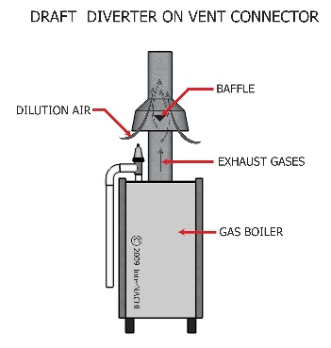
Centered inside the down-draft diverter there was a deflector plate that would re-direct down drafts in the flue into the room rather than into the equipment. Of course, if the burners were operating this would direct all the flue gases into the building but that was considered less of a nuisance. Before going farther, I think the theory behind atmospheric venting needs some explanation.

From most of the articles I have read and some wonderful videos on You-Tube, atmospheric equipment relies on positive buoyancy. Positive buoyancy is the principle of a dense material displacing a less dense material and causing it to float or move in an upward motion. If you lay on your back in a swimming pool and float that is considered positive buoyancy, but if you sink it would be deemed negative buoyancy. In this case we are talking about the density of the combustion gases versus the surrounding air temperature. Atmospheric pressure and humidity also come into play.

This would be logical if the equipment was installed outdoors and only influenced by outdoor conditions. A few things as far as combustion is concerned that come to my mind that work based on natural buoyancy and atmospheric pressure are campfires and forest fires and that doesn’t always work when the wind blows.

I find it humorous that I have read articles written on natural buoyancy that state any time an item is heated; its molecules move faster and rise. They may expand, but they still would have to be less dense then their surroundings. Maybe that is why there are lids on barbecue grills, so our food doesn’t float away?

When equipment is installed indoors it is subject to two pressure zones, outdoor atmospheric pressure and the indoor stack effect of the building and/or building leakage. Then there is the resistance or pressure drop of heat exchangers, boilers sections or baffles in water heaters. In order for the hot combustion gases to rise up and out there must be enough denser air to displace it and overcome this resistance. Also, there is a restrictor plate or down-draft device in mushroom diverters that the hot gases must get past.

With minimum test equipment our forefathers were aware that a certain height or a minimum vertical rise would be necessary to allow enough dense air to display the hot gases. They also were aware that internal building conditions could affect this. In the original installation instructions of mushroom down-draft diverters, it stated that they had to be mounted at a minimum height on top of the equipment. This was usually 12 inches. This could be less if the heat exchanger was taller. Then a smoke test would be performed and if the smoke did not pull in freely, the diverter needed to be raised another 12 inches. Much like today, this only simulates one set of conditions and as we learned in the NCI class, this does not verify venting, only a venting action. Nonetheless this was at least something to address existing environmental conditions at the time.

Now a new problem faced manufacturers as the height of the ceiling in the mechanical room were being built lower. Their equipment was now too tall to be installed in the room with the movable mushroom diverter. Was it possible to build the drafthood into the equipment and shorten its height? Along came the attached or built-in drafthood in the 1950’s and 1960’s.

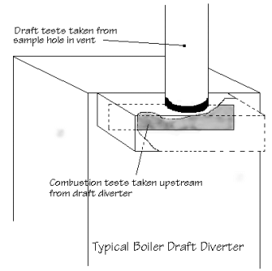
Could these draft diverters be adjusted to overcome equipment pressure drop and internal building conditions? Were these new draft diverters, now called drafthoods, tested to function under real field conditions or unrealistic lab conditions? I would think everyone knows that things tested and certified in labs are under ideal conditions that rarely occur in the field.

Drafthood equipment is tested in a lab that has controlled ventilation to keep the room neutral or slightly positive. It is tested with 5 feet of vertical pipe and 2 elbows. Humm, I am not aware of anywhere that condition has ever been found in the field. Further description or specifications on drafthoods is they work safe with 40% to 50% dilution air. This would imply they work unsafe at different dilution rates but this usually is ignored. Sort of like being told when you skydive you need to pull your shoot at least 300 feet above ground. No mention there of what happens if you don’t, but odds are you won’t repeat this mistake more than once!

With no adjustable control how is dilution air going to be maintained? When looking at NCI Combustion Diagnostic Charts we see that the design draft for all drafthood equipment is -.01” w.c. to -,02” w.c.. as measured in the flue above it. This is the approximate draft the 40% to 50% dilution air occurs. But this also depends on environmental conditions. If dilution air is 50% in the flue then the flue gases should be 50% which means the flue would be sized for quantity of both. We might notice that with the 80% induced draft furnaces or equipment without dilution air added, the flue size is 50% smaller.

There are two definitions of drafthoods, one in the National Fuel Gas Code and one in the ASHRAE Equipment Engineering Manual and are as follows:

National Fuel Gas Code – Z223 – 54
3.3.32

A nonadjustable device built into an appliance, or made part of the vent connector from an appliance, that is designed to (1) provide for the ready escape of the flue gases from the appliance (into the building) in the event of no draft, backdraft, or stoppage beyond the drafthood.

(2) prevent a backdraft from entering the appliance and (3) neutralize the effect of stack action or draft of the chimney upon the operation of the appliance.

ASHRAE Equipment Fundamentals Handbook

Drafthood functions are to isolate the appliance from venting disturbances: updrafts, downdraft or blocked vent; and allow the initiation of combustion without any venting action.

Despite its importance as a vent inlet fitting, the drafthood designed for a typical gas appliance, represents a compromise of many design criteria, and tests only applicable to that appliance. (Could this mean you cannot replace the original drafthood with one made by a sheetmetal shop?)

Keeping pilot from blowing out in the early years before safety pilots made sense. Preventing the draft from removing the by-products of combustion from the heat exchanger doesn’t seem to be as rational, unless you are discussing excess draft from removing too much heat too fast!

In a recent post on the internet,- it was mentioned that, “If you have high draft in the flue and it is connected to the equipment, it will pull all the oxygen out of the heat exchanger and there won’t be enough left for combustion. Yes, you can learn many things on the internet!

The biggest problem with a drafthood is that it allows equipment to operate with a restricted or blocked flue. Could this be some type of population control device? But they all have blocked flue switches, right! I have yet to see a residential drafthood water heater with a factory installed blocked flue switch. In fact, when I wrote an article in a trade magazine years ago I was condemned for tampering with equipment to make it safer. But even then, does a blocked flue switch determine if something is venting or not? The answer is no because it can be spilling out the burners especially during high draft conditions.

Testing a draft diverter or drafthood for spillage or proper venting, has many
recommended procedures or should I say misconceptions. From the beginning using some kind of smoke and watching it pull into the draft diverter was the most common practice. Up until 1999 the National Fuel Gas Code recommended using a cigarette, cigar, pipe or match for this test. I bet no one knew the tobacco industry was on the code board. Just kidding! Now it is recommended to use a match, candle or passive smoke. But wait, there is another inexpensive way to check. Just wrap your hand around the outside of a mushroom draft diverter or put it inside the attached drafthood. If you don’t get burned the equipment is venting. If you suffer from 1st degree burns it is spilling slightly. However, if you encounter 2nd or 3rd degree burns the equipment is spilling excessively and needs to be turned off immediately before seeking medical attention. Did I say inexpensive?

A few other methods are using a mirror, camera lens or cell phone and holding them next the draft diverter or drafthood. If they fog up, you are spilling. If they melt you are spilling excessively! I believe Forest Gump said it best and no, not a box of chocolates.

In the beginning the downdraft diverter might have made some sense. Because they were moveable, they could be somewhat adapted to existing conditions. If every piece of equipment with these draft diverters or drafthoods had adequate spill and flame roll-out switches, the possibility of equipment operating unsafe would be minimized. On the other hand having proper safety switches might create a bigger nuisance because equipment would be failing more often than the old problem of pilots blowing out.

For over 40 years I have experienced the dangers of draft diverters and drafthoods. In 1993, a test in the field with AGA Labs, verified the poor performance of draft diverters and drafthoods. In there report it stated that removing or blocking draft diverters or drafthoods and replacing them with double acting barometrics, improved the safety and operation of all equipment tested. Eighteen out of eighteen had tested unsafe! I believe that report is now filed under expired.

Warning: 1. Never install any type of venting fan above a drafthood!

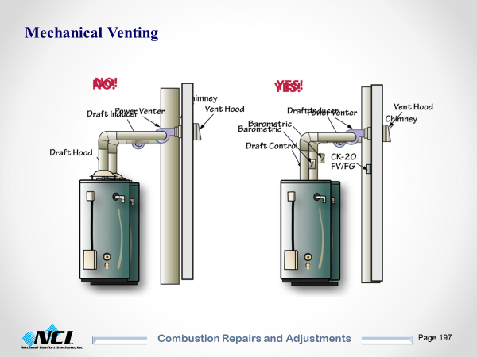
(need this picture of water heater with draft inducer only as in manual.)

2. Never use a horizontal drafthood fabricate by a sheetmetal
company!
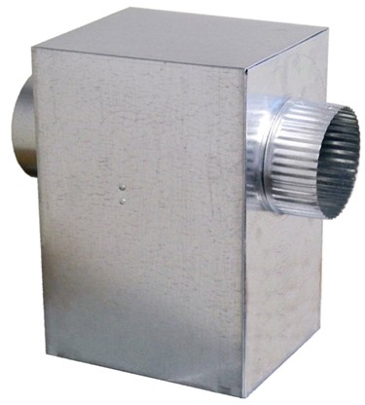

Finally, when I see videos of persons explaining how drafthoods adjust for different drafts and environmental conditions, I think to myself, how does an inanimate object adjust?

