8618504 - M00K00187

Door #1 – Outward Opening
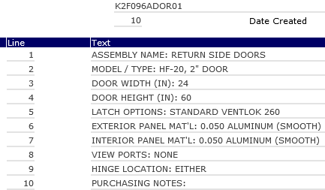

Door #2 – Outward Opening
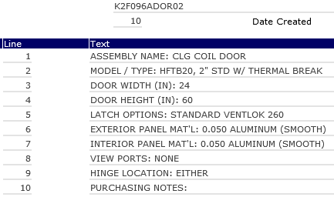

Door #3 – Inward Opening
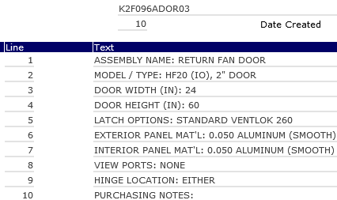

Door #4 – Outward Opening
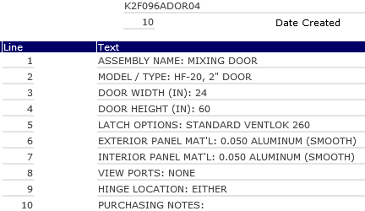

Door #5 - Inward Opening
