NORCOLD N180.3X THREE-WAY (AC, DC and PROPANE) REFRIGERATOR OPERATION
IMPORTANT INFORMATION
The following summary of how to operate the refrigerator is not intended to replace the manufacturer’s instructions. Therefore, you should review the Norcold owner’s manual for a complete understanding of how your refrigerator operates and to troubleshoot problems should they occur. If you do not have a paper copy of the owner’s manual, it can be downloaded from the Norcold website https://norcold.com/ (click on the “Support” tab to find the product manuals.) Additionally, you should read these supplemental instructions in their entirety before using the steps described for operating the refrigerator.

The Norcold owner’s manual provides essential information regarding how to properly load the refrigerator food compartment for good air circulation and best cooling performance. Additionally, it provides the following cautionary statement: “The refrigerator is designed to operate within 3°off level front-to-back and 6° off level side-to-side (as looking at the front of the refrigerator.) Operating it at more than these limits can cause damage to the cooling system and create a risk of personal injury or property damage. Make sure the vehicle is level before you operate the refrigerator.”

Per Norcold, before using the refrigerator, it is recommended that you first ignite (using propane gas) or start up (using AC power) the refrigerator and allow it to get cold for a minimum of eight hours (e.g., overnight) before loading it with food or drinks. If you have access to AC power, that is the most efficient way to initially cool the refrigerator. The DC operation is not intended for the initial start-up and cooling of the refrigerator. Therefore, DO NOT USE DC (12-Volt battery) POWER for this purpose. The refrigerator is designed to operate using DC power only while you are towing your camper (i.e., in transit) and AC power or propane are not available.
The refrigerator should be operated on DC power only when the vehicle engine is running and your camper battery is in a fully charged condition. Assuming your tow vehicle battery is in good condition and the engine alternator is adequately sized, plus your seven-way power cord between the tow vehicle and camper is properly wired with a 12-volt charge line to the camper, the tow vehicle will keep the camper battery sufficiently charged to maintain the temperature of the refrigerator and its contents when they are already cool.
WARNING: Operating the refrigerator using only the camper battery (i.e., without being connected to a tow vehicle with the engine running) will rapidly discharge the battery.

CONTROL PANEL CONFIGURATION
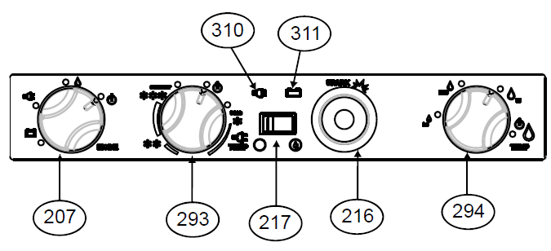
207 – Selector Switch (battery, electric, or propane.)
293 – Electric (AC) Thermostat.
217 – Flame Meter.
216 – Piezo Lighter.
294 – Propane Gas Control.
310 – Electric (AC) Power Indicator (green light - plug icon.)
311 – 12-Volt (DC) Power Indicator (green light – battery icon.)

OVERVIEW OF THE REFRIGERATOR CONTROLS
The Selector Switch (207) is used to select the power source: Propane Gas (flame symbol), AC (electric plug symbol), 12-Volt DC (battery symbol), or “OFF” (power off symbol.)
The Electric AC Thermostat (293) controls the temperature setting when using electricity. The Electric AC Power Indicator (310) will display a green-lighted plug symbol when AC power has been selected.
The 12-Volt DC Power Indicator (311) will display a green-lighted battery symbol when DC power has been selected.
When the Selector Switch (207) is set for propane gas, a (non-electric) Piezo Lighter (216) is used to create a spark, which ignites the flame in the refrigerator burner. The Flame Meter (217) shows if a flame is present in the burner. The Propane Gas Control (294) sets the temperature setting of the refrigerator when operating in the propane gas mode.
IGNITION – PROPANE GAS OPERATION
Under normal operating conditions, with a properly maintained refrigerator, if you follow the below instructions, your refrigerator should be easy to ignite when using propane gas:
- Slowly open the valve at the propane gas storage tank. Opening the valve slowly will reduce the chance of tripping the safety shutoff in the propane regulator, which will turn off or limit the flow of propane.

- Turn the Selector Switch (207) to the propane gas position (flame symbol.)
TIP: It is often helpful before lighting the refrigerator burner if you first light one or both of the stove top burners. It may take a few attempts to light those burners, but doing that will help draw propane into the gas lines and expel any air in those lines, which in turn will make it much easier to light the refrigerator burner.
- Turn the Propane Gas Control to the HI position (third flame symbol displayed behind the control knob), which is located at approximately the 1:00 o’clock position of the control knob (just as the setting for the control knob (294) is depicted in the above diagram.)

- Push and hold in the Propane Gas Control (294.) This will start the gas flowing to the igniter.

- Push in the Piezo Lighter (216) several times in rapid succession for about five seconds to ignite the propane gas flame. (NOTE: Per the Norcold owner’s manual, “Do not hold in the gas control for more than 30 seconds. If there is no flame in this time, wait at least five minutes before you try ignition again. If you continue to hold in the gas control, LP gas will collect in the burner area. This could cause a fire or explosion and result in dangerous personal injury or death.)

- When properly ignited, a flame will be present at the refrigerator burner and the flame meter (217) will slowly move to the right and into the green area of the meter. Once that occurs, wait about five seconds before releasing the Propane Gas Control. IF the flame meter does not move into the green area, repeat the above process (starting with Step 4) after waiting a sufficient period for any lingering gas to dissipate from the burner area.

- Use the Propane Gas Control (294) to set the desired temperature setting. Push and then turn the control knob to either the LO, MED, or HI setting. HI is the coldest temperature setting. These temperature settings are represented by a series of three flame symbols of progressively increasing size, displayed from left to right (i.e., clockwise) around the Propane Gas Control: “LO” is the smallest flame symbol; “MED” is a medium-sized flame; “HI” is a larger-sized flame. There is a fourth, even larger flame displayed adjacent to a power off symbol at the furthest clockwise point around the control knob. This is the setting for turning the propane function “OFF” and is where the knob should be set when not operating the refrigerator on propane gas.

With a full, or nearly full refrigerator, you may find that the MED setting is a good setting to start with. Over time, you will determine the best temperature control setting for proper cooling. That setting will likely be impacted by the outside air temperature. Norcold clarifies in the owner’s manual that, “This is not an automatic gas control. It does not change the flame from high fire to low fire as with other RV refrigerators. If the cooling load changes, you must manually change the gas control to maintain the same temperature inside the refrigerator.” You may find it helpful to purchase a small refrigerator thermometer for monitoring the refrigerator compartment temperature.

START UP – AC (ELECTRICAL) OPERATION
When 120 volts AC power is available:
- Turn the Selector Switch (207) to the AC position (plug symbol.) The AC Power Indicator (310) will display a green-lighted plug symbol when AC power has been selected.

- Turn the Electric AC Thermostat (293) to the desired temperature setting. The temperature settings are represented by snowflakes (HI – three snowflakes; MED – two snowflakes; and LO – one snowflake.) With a full, or nearly full refrigerator, you may find that the MED setting (two snowflakes) is a good setting to start with. Over time, you will determine the best temperature setting for proper cooling. That setting will likely be impacted by the outside air temperature. You may find it helpful to purchase a small refrigerator thermometer for monitoring the refrigerator compartment temperature.
IMPORTANT: For AC operation of the refrigerator, you need both a properly functioning 12V battery and a properly working power converter. Also, do not use a converter or battery charger to supply the DC power directly to the unit, because these two devices do not supply filtered DC power. IF NO ELECTRIC POWER: Check to see if the refrigerator is plugged into the 120V outlet, which is located under the sink, on the right inside wall of the cabinet. Also, check both the 12V fuse and 120V circuit breaker assigned to the refrigerator.

START-UP – DC (12-VOLT BATTERY) OPERATION
The sole purpose of operating the refrigerator with a battery is to maintain the refrigerator compartment temperature when AC or propane gas energy are not available (i.e., while in transit and towing your camper.) Therefore, the refrigerator should be operated on DC power only when the vehicle engine is running and your camper battery has been maintained in a fully charged condition.
NOTE: When both AC and DC power sources are supplied to the refrigerator, it defaults to AC power. When the refrigerator is disconnected from shoreline power, and AC is no longer available, the refrigerator switches to DC operation. It helps to think of the converter as the main 12-volt DC power system along with the house batteries, and the batteries function as your backup. If the bbttery is nearing empty, then the power converter will have a hard time keeping up with the demand when many 12-volt DC systems are in use. This can cause 12-volt systems in the trailer to not work properly.
CAUTION: There are varying opinions as to whether it is appropriate and/or safe to operate an RV refrigerator on propane while towing a camper/trailer. Some feel it is perfectly safe. However, keep in mind that in the event of a traffic or other collision, should a gas line break and be exposed to a spark or fire, a propane gas explosion is very likely to occur. Further, you should never operate a propane gas refrigerator with an open flame present while re-fueling your tow vehicle at a gas station. Also, it is illegal in most (if not all) states to operate an RV refrigerator on propane gas while travelling through a tunnel. For safety reasons, when not using propane gas, it is advisable to turn off the propane storage tank valve. Finally, some RV owners find that they have no problem keeping their refrigerator contents adequately cool while towing without the necessity of using propane or battery power. As long as the refrigerator has been properly cooled before towing the RV, if you keep the refrigerator door closed as much as possible and the refrigerator properly packed (including possibly adding frozen foods or a small ice pack), the temperature should be adequately maintained while enroute to your next destination.

FINAL COMMENTS
A gas absorption refrigerator is not designed to operate in freezing temperatures. If not equipped for low temperature operation, and the refrigerator is exposed to temperatures of 32° F, or lower for an extended period of time, the refrigerator operation may be disrupted. The refrigerator operation will resume when the cooling system of the refrigerator warms sufficiently. Also, whenever the outside air temperature is below 50° F, the refrigerator may have a tendency to freeze food at the colder temperature settings. To reduce the tendency to freeze food, you can (a) turn the Propane Gas Control knob (294) to the “LO” position, (b) keep the refrigerator full of previously cooled items, and (c) place foods that are more likely to freeze on the lower shelf.
When you operate the refrigerator on propane gas at altitudes higher than 5000 feet above sea level, you may experience reduced cooling performance AND you may experience burner outages. To avoid these possible problems, Norcold recommends that you operate the refrigerator on AC when at altitudes higher than 5500 feet above sea level. Obviously, this is not always possible, but it is helpful to be aware of why you may experience a decrease in refrigerator operation or temperature at higher elevations.
(by @Bayliss 07-26-2019; Revised 09-02-2020)

Supplemental Notes:
Refrigerator not cooling:
Per @MuttonChops (07-18-2020):
There are refrigerator fuses under the stove top. However, if the "AC Plug" power-on indicator light is working, those fuses are OK.
It sounds like there are three possible reasons for no AC Power Cooling:
+ thermostat is bad,
+ AC Heater element is bad (open)
+ loose connection at the terminal block, terminal #5.
You could try turning thermostat full range a few times it could be stuck in bad contact position, but that is not very likely.
120VAC wiring (below) in Red. (Norcold Owner’s Manual):
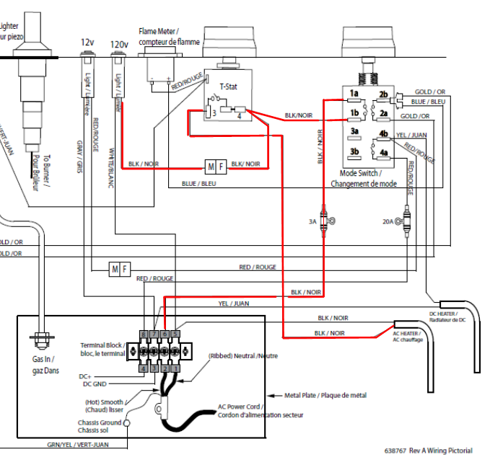
By @B0atguy (07-18-2020):
If you feel heat coming out of the top outside vent (by the trailer door), the fridge IS working, even though it may not be cooling. These fridges are NOTORIOUS for not working if they are not PERFECTLY level. The camper must be perfectly level for the fridge to work on ANY setting, 12V; 120V, or propane. If they are not level, it will not cool, even though it may be trying to. If the "plug" indicator light is working, it’s not an electrical problem.

One other thing to check, which was a common problem on the 2019 320's. Look inside the top fridge vent on the outside (by the door) to see if the insulation "board" has fallen down from the underside of the counter. If loose, and is blocking the top vent, even a little, that will trap the heat transfer. You can also put your hand on the right-hand side of the counter top to see if it is warm/hot. If the insulation board has fallen down, it will need to be re-glued to the bottom of the counter top.

By @Michigan_Mike (09-02-2020):

Another thing to consider is “what you have in your fridge and is it packed up with food?” The 3-way fridge does need to have air circulating within it to be efficient. If things are jammed in tightly, this could create problems with the unit cooling efficiently and maintaining adequate temperature to keep food fresh and from spoiling. These units can be finicky and in hotter temperatures they can be less efficient and can struggle to keep things cold. My fridge actually performs best on propane and there is a difference if you have it sitting in the driveway unpacked vs at the campground with a full load of food.

VENTILATION:

BY A NORCOLD REPAIR TECH (but, in 2015, and not specific to the T@B refrigerator): The venting or ventilation on the side of the refrigerator is more and more important the more extreme the outside ambient temperatures get. This being said, a poorly vented refrigerator will most likely have no issues if running in moderate ambient temperatures at all times. However, weather is unpredictable, and when you add in the fact that RVs are typically moving, it just makes a well vented refrigerator crucial to keeping food cold. The refrigerator has a gas absorption style cooling unit. The cooling is first initiated by a heat that is supplied at the cooling unit. This heat is either an AC heating element, or a burner when operating it on LP mode. The ammonia vapors then rise up the rectifier tube and make its way to the top of the cooling unit. There are a bunch of fins closely fit together at the top of the cooling unit. These fins are called condenser fins, because this is where the condensation begins (where the cooling begins). Airflow across those fins is what actually causes the condensation in the first place. Poor ventilation prevents this process, or at the very least hinders it. The typical symptom here would be a freezing freezer section and a poorly cooled refrigerator section. The reason for this is that there simply isn't enough ammonia solution flowing through the system (not enough condensation is being created at the condenser fins.) The cooling unit is all gravity operated, so if you know the cooling process has begun at the top in your freezer section, you can also know that it is very likely that you have a venting issue. If you plan on camping in very hot ambient temperatures, we recommend installing a fan to help with air flow.

By @jules2go (09-01-2020):

Looking for some thoughts on a mystery with my 2020 320s Boondock's Norcold fridge. At home when I'm hooked up to shore power the fridge works great. When I get to the campsite and hook up to electric, it stops. Second time at a campground this past month and the same thing happened; this last time a maintenance guy changed out the receptacle on the outlet for the site, and still doesn't work. I've called Nucamp and they don't have any ideas. I've flipped the breakers on and off at the power source and in the camper. I also can't get it to run on propane; propane is turned on, set to "propane", needle is in the green zone. I hate to have to take it back to the dealer (1.5 hours away). I'm also having weird things with the electric outlet at the rear on "passenger" side. It is not always functioning.

One thing I didn't mention is that, so far, I've camped less than 7 times with my T@B, and I believe it HAS worked on shore power at a campground at least one or two times. And I do recall that I've been at a site a couple of times or so where I only had 50-amp service at the campsite. I used my 50-amp converter thing when there (along with the surge protector, as always). But, I don't recall if those were times when the fridge worked on shore power or not, because it's been only the last 3 campgrounds where it's not worked consistently which has now caused me to be annoyed and concerned enough to start making mental notes about it all. I need to keep a written log of all the variables going forward. My current campsite has 30 and 50-amp option; I'm going to try using the 50-amp outlet when I get back to the site (with the 50-amp converter thing) and see if it makes a difference, just for the heck of it.

I have it on at least 24 hours before a trip and it's very cold. Longest trip so far is only 2.5 hours, yes, enough to warm up. But by the morning, everything is getting warm.
BUT! News to report!! I came back to my campsite tonight and tried hooking up to the 50-amp outlet, with my 50-amp converter thing, and VOILA. It is working!!! So, at this point, I don't know what to think. At home, I'm not plugged into 50-amp. But those couple of campsites I've been to that only had 50-amp service, I guess I was getting juice to the fridge. If it was the 30-amp power cord, then it wouldn't work at home, right? Hopefully this will be a good clue for all the wonderful sleuths here. I have zero idea of what the issue is. Glad it's working though. So, my 2020 T@B 320s isn't 50-amp, right? Isn't it 30 amp? Why would the AC work with the 30-amp, but not the fridge?

By @JEB (09-02-2020):

You likely have a short in your trailer’s electrical system where a neutral is going to ground and the fault is causing GFCI-protected circuits to pop and cut off AC power. The key is when you said that you were able to get stable power using a dogbone on a 50-amp power source. 50-amp outlets are not GFCI protected, because the NEC does not require it. Technically, the NEC does not mandate that 30 amp service be GFCI-protected, either, but many campgrounds use GFCI breakers on 30 amp circuits anyway out of an abundance of caution.
This is not an easy (or cheap) problem to fix, because first you need to convince the dealer that he has to plug into a GFCI protected outlet even to discover the problem. Most service bays have 50-amp and the dealer, like you, just uses a dogbone whenever he needs power. If he does that, he’ll simply say it works fine for us and you’ll be out of luck getting a diagnosis.
Second, if you can get the dealer to plug into a GFCI protected outlet and trip the breaker, isolating the fault will take some time. He has to deenergize every circuit and reenergize each one (one by one) until he finds the circuit with the fault. Once he does that, he might not even be able to identify exactly where the fault is occurring (or access it easily) and will have to run a bypass. It’s not a cheap fix if you are out of warranty.
Three things you can do to confirm the problem and work around it while you ponder your options. (1) You can continue to use a dogbone on 50-amp service. None of the 50-amp sockets are GFCI protected from what I’ve seen. (2) You can look around for 30-amp service that is not GFCI protected. This can be easy or hard, depending on where you live or travel. Federal parks don’t seem to use GFCI protection on 30-amp. But some state parks systems, like those in the Illinois, use GFCI on 30-amp service almost exclusively.
There is a third option, but it’s potentially dangerous and you should use it only if you have a dire emergency and need power to run something like a medical device. Take a 20-amp to 30-amp dogbone and use a pair of pliers to pull out the neutral pin. It’ll work, because there’s no neutral going back to the GFCI breaker making the neutral to ground fault in your trailer’s electrical system irrelevant, but YOU might become the ground if you touch something on the frame of the trailer. Then you need to hope the GFCI works as intended because it will immediately pop the breaker and cut AC power.
This problem is more common than you would think. I actually learned the dogbone trick from a camp host in Illinois who sees it occasionally and keeps a couple of these MacGyvered 20 to 30-amp dogbones on hand. But the problem often goes undiscovered even if present if you are lucky enough to always use 50-amp service or 30-amp service that has no GFCI protection.
I hope your issue isn’t what I think it is. It’s frustrating and expensive to remedy. But it sounds very familiar.

