EQUALITARIAN PEOPLES ASSOCIATIONS
EQUALITARIAN PEOPLES ASSOCIATIONS 1
Equalitarian Peoples Associations 1
Statutes and mission 2
Periodic Budget 2
Structure 3
Members 3
Private corporations 6
Governing bodies 6
Public service enterprises 6
Monetary system 8
Commons Sovereigns 8
Member’s accounts 9
Peoples Bank and other public accounts 11
Economy 12
Legal Tender currency 12
Membership Fees and Basic Income 13
Volunteers payment 15
Life cycle of the Commons Sovereigns 17
The social amplifiers 19
Inspirations and Signature 19

Equalitarian Peoples Associations
Equalitarian Peoples Associations are NGO’s with charitable, service, participatory or empowering orientation. Examples can be parties, social movements associations, workers unions, etc. They may provide services or goods in addition of political activities.
They are similar to other solidarity businesses and enterprises in which the main aim is to put into the parallel economy a service or a good. These enterprises need to have a positive or not negative result. For them, the kind of currency that is better suited is a currency based on a contract to deliver the product. An example could be a cooperative to grow vegetables.
The special feature of Equalitarian Peoples Associations when they provide services or create goods is that they rely on donations in money, donations in goods and or voluntary work. These wares are the commons. The logic is that of a public service. Nevertheless, the boundaries are not sharp.
By Equalitarian we mean that these associations are voluntary and all members have the same rights and obligations at their decision making process, the discussion and voting process. It is the democratic civil rights.
Equalitarian Peoples Associations members may have different rights and obligations towards the organisation activities and organisation benefits, like donations or voluntary work, according to needs and capabilities. Obligations are voluntarily accepted on a case by case basis as an individual voluntary decision linked to a contract or at accepting a mandatory collective decision involving the participation at an activity (i.e. payment of the membership fee), the non-acceptance implying loss of membership. It is the public welfare rights.
At small scale an example could be a charity association running a charity kitchen functioning with regular or occasional donations in money, donations in food and voluntary work.
At large scale could be a local or national state, delivering welfare state benefits, functioning with taxes and public servants.

Statutes and mission
Equalitarian Peoples Associations have democratic statutes, or a constitution, which is a statute contract signed and committed by all members. Equalitarian Peoples Associations statutes include a mission. The statute defines the democratic processes and the bodies running them, and the types of actions to achieve the goals of the mission and the bodies in charge of executing them. The statute, and the mission, can be changed following a democratic process according rules included in the statute, and by a majority indicated in the statute.
Equalitarian Peoples Associations have a periodic action plans implying periodic budgets. By default, the period is a year. The action plans are social actions for the benefit of the Equalitarian Peoples Association members and other social targets specified in the mission. The action plan and the budget are decided trough a democratic process as indicated in the statute. The action plan and the budget are periodic contracts that are ancillary annexes of the statute contract, and need to be signed by a majority of the members, a majority specified in the statutes. The management of the action plan may include further democratic consultations during the period for the details or adaptations of parts of the action plan.

Periodic Budget

Incomes and Expenditures
The budged of an Equalitarian Peoples Associations periodic action plan is expressed in incomes and expenditures.
Incomes have these main budget lines:
- Money issued out of the nothing by the members, in their monetary sovereignty, for this period and lend to the Equalitarian Peoples Association. Nowadays, this function of lending money to the state is only reserved to the banks in the Fractional Reserve Banking System. The function is democratised to let anybody do it.
- Membership fees or taxes due by the members in this period and collected by the Equalitarian Peoples Association.
- Other donations.
- Savings from previous period.
Expenditures have these main budget lines:
- The cost of running the public bodies. It is the cost of the democratic process.
- Expenditures to deliver the social actions indicated in the action plan and executed by the public service bodies. Some of the expenditures may be investments. It is the cost of the social benefits.
- The cost of the basic income due and paid to all Equalitarian Peoples Association members. We classify it as different to a social benefit as it is only monetary machinery but not real goods.
- Money in the Peoples Bank that is returned to pay the loans.
Mandatorily, at each periodic budget, the incomes equal the expenditures within the period. There are donations but no loans from the outside. Lending of any money at any currency, including Commons Sovereigns, by the Equalitarian Peoples Association governing body or any public service enterprise is prohibited.
Exceptionally there may be savings from one period passed to the next. No income can be included as a debt for the next period.

Economy
Once issued and spend by the Equalitarian Peoples Associations, the Commons Sovereigns will circulate in the free market of Open Money, having an economic impact beyond the actions foreseen in the periodic action plans.
This may impact notably the monetary mass of Commons Sovereigns available inside the Equalitarian Peoples Association community for the Periodic Budget circuit.
Equalitarian Peoples Associations have no ambition to rule the free market economy around them, but discussing a Periodic Economy Forecast beyond the Periodic Budget, the State Budget, is necessary to the Monetary Policy chapter at the discussion of the periodic action plan.

Structure

Members
New members are admitted following rules indicated in the statute and according a voting procedure amongst old members as indicated in the statute contract. Once accepted as member, the new member signs the current version of the contract statute and all the rights and obligations for the members included in them. He acquires the right to vote and obligation to sign approved changes in the statute contract and the right to vote and obligation to sign the periodic plan contracts.
The failure to participate in the democratic decision process, that is, not exercising his/her rights to participate in the decision process, including the voting, or not accepting and not decisions taken by the majorities as specified in the statute rules, may imply the member expulsion of the Equalitarian Peoples Association. The precise conditions and procedures for expulsion are specified in the statute. These rules are expressed as points added or detracted to the member reputation.
The non fulfilment of his/her mandatory or voluntarily acquired obligations towards the organisation activities may also imply the member expulsion of the Equalitarian Peoples Association. The precise rules are specified in the statute. The rules are expressed as points added or detracted to the member reputation.
In case of dispute of a member, or several members, with the Equalitarian Peoples Association governing bodies with regards a decision process, or with the Public Service bodies with respect his rights and obligations at the organisation activities, an Ombudsman will organise a public court made out of ordinary members of the Equalitarian Peoples Association, following procedures included in the statute contract. The judgement is mandatory to all parts.
Members may trade with each other or create businesses, freely using the Equalitarian Peoples Association Commons Sovereigns or any other currency.

Members Categories

Citizen
Is the default member

Member of Groups
Members can voluntarily join political Groups that vote in the decision process jointly, after a separate internal discussion and with their own majority rules, renouncing to their individual votes. Groups cannot be created to do jointly a mandatory action. Public Managers and Councilmembers have to abandon any Group after being appointed.

Public servants
A citizen may be voluntarily recruited part time or full time as employee of a public body. It has several properties, the public service body, the post, the category, the duration, the working time, and the salary. Public servants are nowadays called volunteers and may not be paid at all, or only provided with subsistence means or payments.
Salaries of the employment posts at the public service enterprises are proposed by the management and fixed with their annual operational costs plan. Acceptance of public servant employee contract with a given salary is voluntary.

Court
It is a property of Public Servants. A citizen may be appointed temporarily as public servant to a court. It has a property, he/she is nominated as a court for a judgment contained in a contract.

Public Managers
It is a property of Public Servants. They have powers over the Public body’s accounts and to sign Public Servants employment contracts and other service contracts with external providers.

Councilmember’s
It is a property of Public Servants. They become employees to the Equalitarian Peoples Association governing body secretariat, a particular case of public body, after being elected. They have powers over the Public Bank accounts, and to sign action plans with the Public bodies. Councilmember’s have a property called post which implies the monitoring of a part of the action plan.

Ombudsman
It’s a special senator’s post.

Members Reputation
Members reputation is a scoring system (for example from 0 to 100) to accumulate points at participating in the democratic life of the Equalitarian Peoples Associations, that is, to fulfil its obligations. The failure results in detraction of points. It’s a measure of the trust behind the Equalitarian Peoples Association contracts.
Decision procedures defined in the statute, or mandatory actions included in the actions plans, indicate the number of points to be added or detracted to the reputation. They are calculated to add to the top value (i.e.100). Points are added or detracted automatically at executing the corresponding contract clause.
There is an average admittance reputation acquired at the member admission. At every period all members are reset to the average reputation.
Reputation is public.
The reputation score does not result in any increase or decrease in the members rights or obligations. At reaching 0 or less it results into automatic expulsion.

Members Capacity
Member’s capacity is expressed in Common Sovereigns paid as membership fee or regular donation or Equalitarian Peoples Association taxes.
It is voluntarily chosen and declared by every member before the discussion of the periodic action plan, so that the income in membership fees is known. Once declared, it becomes mandatory. Members can declare different capacity for each period.
The amount of capacity does not result in reputation points. Equalitarian Peoples Association may choose social network platforms to express this kind subjective social reputation. However, once the capacity is committed, the payment results in reputation points.

Private corporations
Members can create any kind of private corporations. They may use any kind of currency they want.
Corporations are assets with ownership indicated by the shares. Corporations make business and pay dividends.
Strongly suggested is to use a currency consisting of a contract with the bearer to deliver the goods produced by the corporation, a currency that is a merchandise bond. If they want to use ethereum they can work as Decentralised Autonomous Organisations, and issue a currency with an amount representing the total of the goods to be placed in the market. They may also use Common Sovereigns, if they want to do so, as their trade currency.
Their currency thus represents again an asset, the goods to be produced in the next selling period. They exchange these assets with their providers, including workers, as payment for the provision of goods and services they need for production.
Once in circulation, the merchandise bond is obtained from the market, or exchanged, and finally used by the customers to pay the corporations production. The merchandise bond is an auto-loan.
The development of such a system for private corporations is optional for the Equalitarian Peoples Organisations. Other platforms are under development.

Governing bodies
Equalitarian Peoples Associations have governing bodies or Councils with part time or full time Councilmember’s elected democratically amongst the members every period to manage the action plan. Each Councilmember is elected for a particular post. The posts of the governing bodies are broadly defined in the statutes and further specified for each action plan. Councilmember’s may different voting weights according to the post, as broadly indicated in the statutes and further specified for each action plan. At every period a majority of the members sign an appointment contract with the elected Councilmember’s giving them the necessary powers to manage the action plan contract. Payments related to the budget require the signature of Councilmember’s with a majority broadly defined in the statutes and further specified for each action plan, for each budget line.
No member can be elected as Councilmember more than one consecutive period.
At small size Equalitarian Peoples Associations there is usually no need of a permanent assembly like a parliament. The periodic plan can be discussed at a yearly assembly, real or virtual. Changes in the rules of the statute can be equality discussed at assembly, real or virtual.

Public service enterprises
Equalitarian Peoples Associations may decide to have public service enterprises to execute parts of the action plan. They function as autonomous public, social, enterprises.
They are public service bodies, which are publicly funded, and are at the same time social enterprises, that have the capacity to trade. They need to manage the resources efficiently, like companies. They follow usual accounting rules. If they sell the services for a subsidized price, anyhow they need to succeed in the market.
All assets belongings of a public service enterprise are belongings of the Equalitarian Peoples Association statute contract.
The establishment of a public service enterprise is part of a periodic plan, and by default inherited by the next periodic plan, so that public service enterprises have some stability. Public service enterprises may be dissolved at another periodic plan.
Every period, the public service enterprise signs a contract with the governing bodies to do some of the works of the action plan. Public service enterprises are paid out of the budget line allocated to these works. The default payment mode is advance payments and reckoning with real costs after acceptance.
The expenses of the public service enterprises are divided into projects, operational costs and investments.
At the beginning of each period, all public service enterprises prepare and submit a periodic plan made out of projects and operational costs. These plans need to be approved by the governing bodies and are part of the contract.
To do the works, at projects or operational costs, public service enterprises may contract services or goods to members or to any other party. These contracts follow a good administrative practice public tender procedure. Every project implies a contract with the provider. The contract payment is expressed in Commons Sovereigns and can only be paid in Commons Sovereigns.
To do the works indicated as operational costs, public service enterprises may have part time or full time public employees to do the necessary jobs. Public employees, including the management, are recruited and contracted voluntarily amongst and only amongst the members. The governing bodies of the Equalitarian Peoples Association are in charge of the selection and appointment of the public employees. By delegation, the public service body’s managers may do recruitment of non management employees. The employment contract payment, the salary, is expressed in Commons Sovereigns and can only be paid in Commons Sovereigns. Employment at public bodies, including management posts, may last more than one period. The contract for a management post is never less than one period.
Public service enterprises may invest into infrastructures, like office equipment or cooking machines.
The management of the public service enterprises has the powers to sign payments according rules set out at establishing the body. Every payment has to correspond to a contract for the delivery of a good, a service, be it a project or an operational cost, or an employment contract.
The acceptance of the works of the public service enterprises is decided trough a democratic process of all members as indicated in the statute, prior to the process of deciding the next action plan. Some rules of this audit could be something like:
- The people’s rejection of the works implies the automatic resignation of all the management of the public service enterprise and the disqualification to occupy any such post for the next three periods. No further liability is required.
- The public acceptance of works may be prepared evaluations contracted to independent experts, publicly appointed.
- The acceptance of the works implies an audit of the accounts. If the audit detects a misuse of the resources of the public service body, according the principles of economy and efficiency, whether the works are accepted or not, it results in sending off as members of the Equalitarian Peoples Association of the management of the public service body, and they cannot be readmitted for the next three periods. No further liability is required unless the misuse has implied personal enrichment. In that case the governing bodies may claim damages to the general civil justice system.
The incomes of the public service enterprises are the funding received from the Equalitarian Peoples Association governing body and the incomes resulting from the selling of the services.
These enterprises need to have a positive or not negative result. No lending is allowed by any other body of the Equalitarian Peoples Association, ant member, any external institution or person.
A special Public Service Enterprise is the Donations service paying the Basic Income and collecting the donations or taxes.
At small scale an example of a public enterprise could be the kitchen itself of a charity kitchen association; another public enterprise the team collecting the food donations.
At large scale it could be the public schools of a district under one management.

Monetary system

Commons Sovereigns
Commons Sovereigns is a type of currencies designed for Equalitarian Peoples Associations.
The name of Commons Sovereigns is to express that it is a currency to manage the people’s commons with full sovereignty.
The purpose of Commons Sovereigns is:
- Specific to Commons Sovereigns:
  - Using them to measure manage the peoples commons investments and assets.
  - Using them in as a collective means to measure and reward the work of the Equalitarian Peoples Associations public servants. In that sense it would put in circulation a value equivalent to the usually the non-paid voluntary work of the members of the NGOs.
  - Using them as a tool of transfer of wealth between the members of the Equalitarian Peoples Associations that are healthier in terms of debt money to the less healthy members. In that sense it would carry and put in circulation the value of the external donations and membership fees to the NGO.
  - Using them as tickets to pay the social benefits provided by the Equalitarian Peoples Association, if any. For example, beneficiaries of a charity kitchen run by the Equalitarian Peoples Association, members or not, have to obtain Commons Sovereigns either by providing services paid in Commons Sovereigns, or be donated with Commons Sovereigns, to pay their meal.
- General as Open Money:
  - Using them as a voluntary internal trade exchange means of goods and services amongst members of these Equalitarian Peoples Associations and also a voluntarily accepted currency to trade with other Peoples Organisations or other people in general. This is not an essential aim of the Commons Sovereigns, but it is an inherited property of any currency that can be accepted voluntarily for payments. In that sense it would play a role similar to some community currencies used for barter transactions of goods and services, notably working time, like in time banks.
The ultimate aim is to reinforce a parallel economy to the debt money economy, around the solidarity activities of the Equalitarian Peoples Associations, by creating a net differential to pump systematically transferring wealth from the debt money economy. This would reinforce in general the parallel solidarity Economy including other solidarity businesses and enterprises.
Commons Sovereigns design is tightly linked to the Equalitarian Peoples Associations structure, decision process, and functioning. Commons Sovereigns concept is the currency to denominate the transactions to the contracts regulating the relations between the Equalitarian Peoples Association members, governing bodies and public service bodies. In the real world it may have thousands of variants.
The above mentioned contracts are supposed to inspire their implementation as Smart Contracts in Ethereum.

Member’s accounts
Each member has two accounts, the current account and the loans account.
- The current account has to be always >= 0.
- The loans account has to be always =< 0.
There are two types of transactions between these types of accounts, transfer of funds and loans. Transactions have to be always between accounts of different members. A member cannot make any operation between his or her current account and the loans account.
The unit of account is Commons Sovereigns at both types of accounts.

Transfer of funds
If the current account has sufficient funds not to become negative after the transaction, a member can transfer any quantity from his or her current account to another member current account. The receiver can be also any organisation account. It detracts the amount of the transfer from the sender and adds the amount to the receiver. It only requires the signature of the sender. The receiver can reject the transfer afterwards.
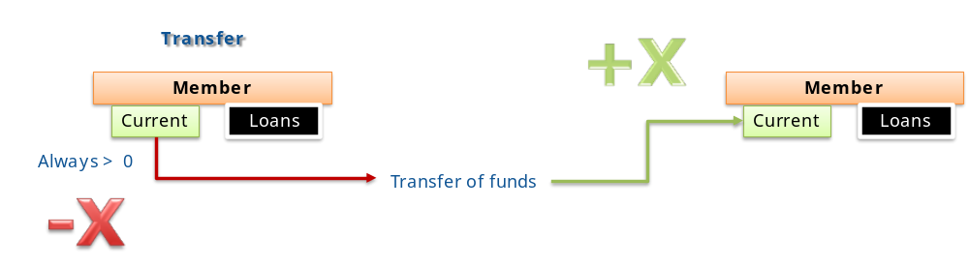

Loans
Any member can transfer out of the nothing any quantity from his or her loans account to another member current account. 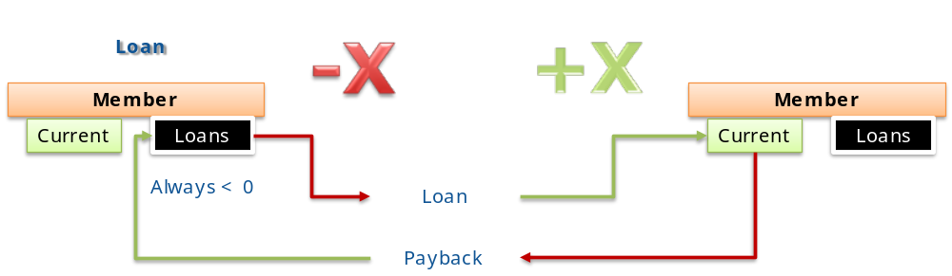
It detracts the amount of the transaction from the sender and adds the amount to the receiver. The receiver can be also any organisation account. It requires two signatures, the signature of the sender and the receiver of the loan accepting the loan.
Lending abuse may result in inflationary effects. Equalitarian Peoples Associations may want to regulate this activity and set some rules. If the Equalitarian Peoples Associations wants to have some control of these operations using these rules, the contract may require a third signature, that of a control body.
The transaction itself is a lending smart contract signed by all parties that includes the automatic payback to the loans account of the lender, at the agreed timing and the agreed conditions.
A variant may include an interest, that is, the payback of the principal to the loans account of the lender and an interest to the current account.
As this is how banks operate now in the Fractional Reserve Banking system, all Equalitarian Peoples Associations people become banks for Peer to Peer lending and thus creating money. If the Equalitarian Peoples Association misses the old banking system, it may authorise the creation of DAO corporations that also have a loans accounts and can give loans out of the nothing.
Public service enterprises have no loans account, and therefore cannot lend money.
The monetary consequence, as it happens at all P2P monetary systems like time-banks, is that there is no fixed monetary mass. The monetary mass grows with the lending and decreases with the payments back. In one word it grows with the intensity of the trust based transactions between peers. Interest payment does not change the total monetary mass, but sucks and detracts money available for transactions of goods.
Other B2C oriented monetary systems, like currencies that consist in a contractual promise of a good (commodity based), need to have a fixed monetary mass. Bitcoin is a special case. It has a fixed monetary mass like B2C systems, but floats in value.

Peoples Bank and other public accounts
The periodic budget of the Equalitarian Peoples Associations is executed in Commons Sovereigns.

Peoples Bank
The Peoples Bank is the account of the Council and manages all incomes and expenditures of the periodic budget. All entries are visible by all Equalitarian Peoples Association members. Payments need to be voted by council members according rules set out in the statute. Payments can only go to Public Service Enterprises.

Public Service Enterprises accounts
Each public body is an autonomous organisation that has its own account in Commons Sovereigns. All entries are visible by all Equalitarian Peoples Association members. Payments need to be voted by their Public Managers according rules set out in the statute.

Exchange services
Anybody, except Equalitarian Peoples Association governing bodies or public service bodies, may establish free market exchange services of Commons Sovereigns with debt fiat money, any other Open Money currency and any other crypto currency. Exchange services are freely available to any business of person selling services or goods to the public service enterprises of the Equalitarian Peoples Associations or trading with the members or anybody accepting Commons Sovereigns.
The governing bodies and the public service enterprises of the Equalitarian Peoples Associations cannot establish an exchange service or change themselves. Members may establish exchange services.
- As the public service enterprises get their budget paid in Commons Sovereigns, goods or services that need to be paid in debt money by the public service enterprises imply that somebody, member or not, accepts to be paid in Commons Sovereigns on a voluntary basis, and then if need be exchange it to debt money.
- Members may exchange debt money for Commons Sovereigns to pay their Membership fees or to obtain services or goods offered in Common Sovereigns. Members may establish exchange services.
Exchange rates are free market rates resulting from supply and demand. Governing and public services bodies are not authorised to exchange and have no say, through ruling, in the exchange rates of the Commons Sovereigns.

Economy
By Equalitarian Economy we mean the part of the economy moved by the Equalitarian Peoples Associations. It does not pretend to become all the economy, which is largely assumed to be free market economy. It is an economy meant to distribute wealth for the healthier to the poor and generate value in the process. We speak about an amplification of the altruist actions.

Legal Tender currency
The Commons Sovereigns currency is the legal tender currency of the Equalitarian Peoples Association:
- All issuing of Commons Sovereigns currency lies on the member’s sovereignty to give their governing body a monetary instrument. The members of the Equalitarian Peoples Associations set each year the equal amount of Commons Sovereigns to be issued by all members.
- All contracts signed by the Equalitarian Peoples Associations governing bodies can only be signed as contracts with Equalitarian Peoples Association public service enterprises, and payments can only be done in their Commons Sovereigns currency.
- Public service enterprises may contract with anybody, but can only pay in Commons Sovereigns. This includes public servants salaries.
- Amongst the obligations of the members of the Equalitarian Peoples Associations is the obligation to pay every period a personally fixed amount of membership donations or fees in Commons Sovereigns. Membership fees have to be paid in Commons Sovereigns.
- Other money donations have to be converted into Commons Sovereigns. There may be donations to the Public Bank or to a specific Public Service. This fosters the competition of public services to get free donations.
- All members of the Equalitarian Peoples Associations are paid a basic income. The basic income is paid in Commons Sovereigns.
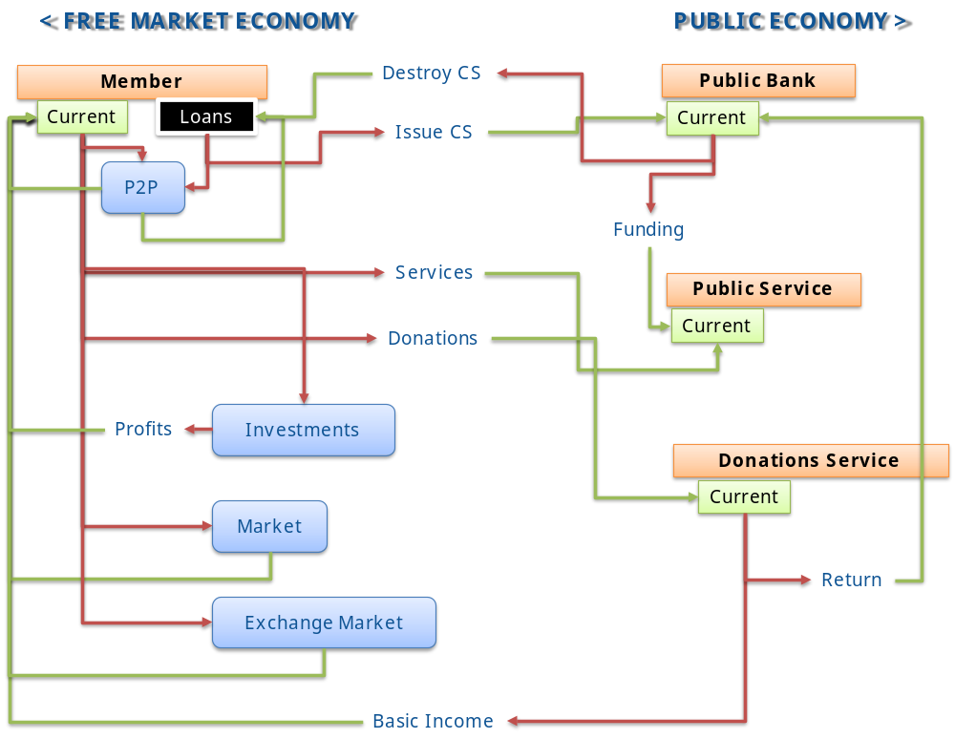
This graphic shows how Commons Sovereigns, used at the public services as Legal Tender Currency, circulates as a complementary monetary tool of the free market as well, exactly as Legal Tender Currencies are doing now. The difference is that there is not anymore monopoly.

Membership Fees and Basic Income
Membership Fees or taxes and Basic Income balance represents the pump to inject value from the debt money banking system to the solidarity economy and distributing this wealth to the poorest.

Membership fees
Membership fees are paid according a time schedule specified in the statutes and periodic action plan. Each member pays the voluntarily agreed capacity. Membership fees are collected in Commons Sovereigns. Experience shows that capacity follows an exponential curve.

Basic Income
The basic income may be defined as an unconditional equal basic income, or a variable according the depending persons of the member, like children or elderly, or to the contribution to the family works, like man and woman. The choice is optional to each Equalitarian Peoples Association. For modelling purposes, we assume it is an unconditional equal basic income.
Basic income is paid in Commons Sovereigns.
At the poorest, may be precarious or unemployed in the debt money world, the net balance of taxes to be paid and basic income is positive in Commons Sovereigns. They may be employed as public servants in the Equalitarian Peoples Association, in which case they have an additional income in form of a salary in Commons Sovereigns, or maybe not. They may spend their Commons Sovereigns by paying services provided by the public service enterprises (i.e. charity kitchen). But they may also obtain good value for the money by exchanging their money with high capacity members needing to pay tax in Commons Sovereigns for debt money paying debt money economy goods and services. High capacity members that have not collected enough Commons Sovereigns through the internal trade may pay good EUROS or USD to the poorest to obtain the Commons Sovereigns needed to pay their fees. They may also exchange their Commons Sovereigns in other Open Money currencies that can be used for products or services in the solidarity economy.
In summary, the Basic income is a net transfer and redistribution of wealth in form of public Equalitarian Peoples Association services or other goods that can be bought with debt money or other Open Money currencies.

Statistical adjustment
At every periodic action plan there will be a statistical adjustment of Basic Income to expected membership fees.
A typical statistic scenario will transfer wealth form the 25% healthiest members with higher capacity to the 75% poorest.
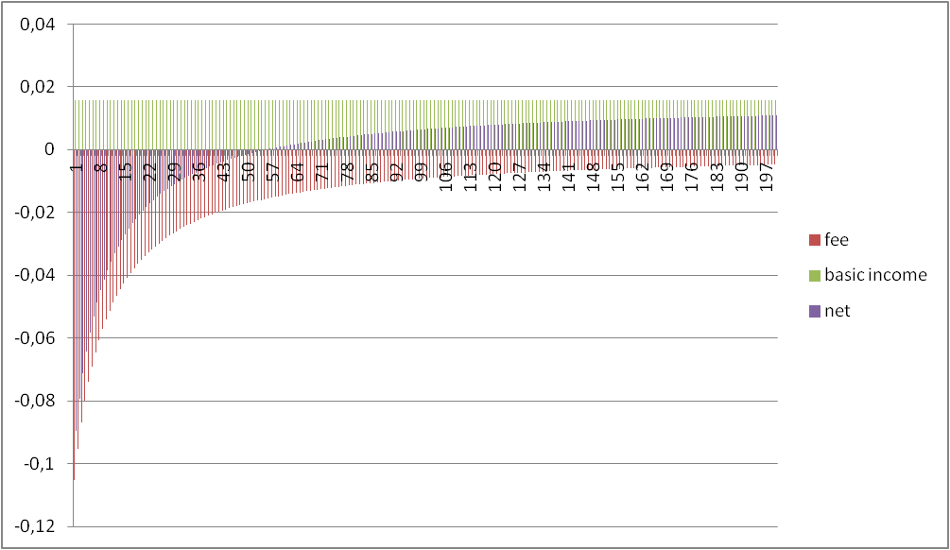

Volunteers payment
Volunteers working part time at NGO, sharing their activities with a job in the debt money economy to get their subsistence, are not paid nowadays. They work in a fully altruistic way, not expecting to get any benefit other than moral satisfaction.
Only full time NGO volunteers are paid a salary in debt money to allow them to survive. Typical is the case of volunteers on mission on third world countries. A different case is the NGO bureaucrats working in the offices, normally a small percentage of all volunteers.
The vast majority of volunteers in the NGOs are paid nothing. We need to monetize this donation of work to move the wheel of the solidarity economy.
We assume that we start from this altruist spirit. We will assume that volunteers, the public servants of the Equalitarian Peoples Association, are paid just for symbolic purpose. For convenience of exposition we assume that public servants on a basic post are paid 1 Common Sovereign for 1 hour of work. It does fit very well with the currency used in Time Banks, the HOUR.
If we measure the prices of all goods and services in terms of their equivalent value of labour, a public servant being paid in Common Sovereigns will only expect to be able to buy, for his HOUR of work in the Equalitarian Peoples Association public service, no time of commercial services in the debt money world.
However as other members of the Equalitarian Peoples Association start to offer their services in the free market for the Common Sovereigns they need to pay their fees, one HOUR paid to volunteers in Common Sovereigns starts to have a value in the internal market. A volunteer mother may use Common Sovereigns to pay somebody to baby sit her kids while she cooks in the charity kitchen. It means that a small egoist advantage is already introduced with respect the current situation in which they get paid nothing.
We call the ratio of the marketable value of the Common Sovereigns salaries the egoist ratio. This egoist ratio will determine the exchange rate of the Common Sovereigns in the exchange market.

Volunteer pay and exchange rate
The exchange rate of one Common Sovereign will fluctuate initially around the price of one hour of work in the debt money economy times the egoist ratio.
Nevertheless, internal trade made with other people using Common Sovereigns will soon use the same time of work equivalence. In the internal market, if the public service enterprise pays 1 CS per working hour, time banks will soon tend to pay 1 CS for one hour.

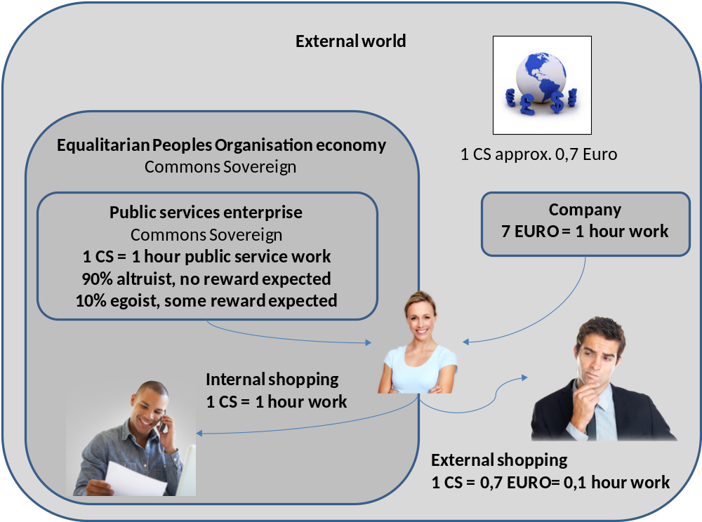
Egoist ratio 10%
This provides a tremendous incentive to buy internal, speeding up the growth of an internal market of goods and services in Common Sovereigns.
The small egoism of the former volunteers, now public servants, is the most powerful engine for the growth of the solidarity economy.
This growth is not in contradiction with the aims of a sustainable, not GDP growing economy. It’s a growth based on conquering new economic areas. Once conquered, they should be designed in a way more resource efficient, resilient, recycling and sustainable. The GDP of each of the conquered areas should decrease.
In the long run, if the new economy is to take over the Fractional Reserve Banking money economy, this low egoist ratio cannot be given for granted for the public servants. In the long run, full time public servants should be able to earn for a living. The egoist ratio should grow to 100%.
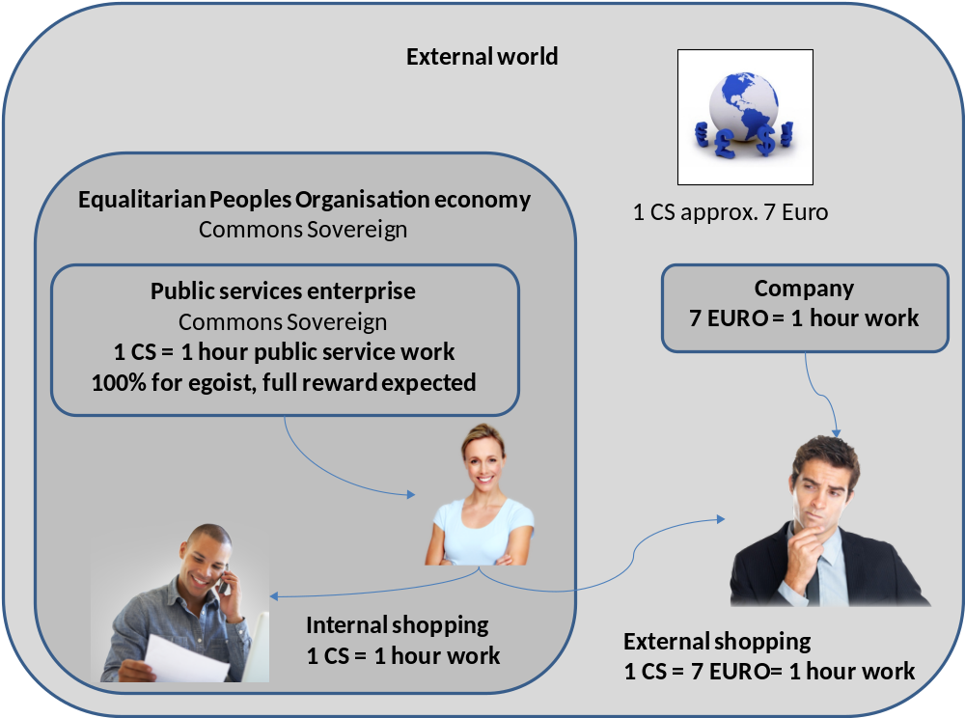
Egoist ratio 100%
The tendency over the years is that the exchange rate of 1 CS equals the price of a working hour in all external currencies. It only means that all currencies exchanges turn out to pay the same amount of working hours in all currencies.

Export and imports
A low egoistic ratio at the start will be also a strong incentive to external players to import goods and services from people or enterprises working in CS. For the price of a working hour in the debt money economy you can buy the reverse of the egoist ratio number of working hours in the Equalitarian Peoples Association economy.
His is an additional thrust for the growth of the Equalitarian Peoples Associations economies over the debt money economy until they reach an equalitarian equilibrium between them.

Life cycle of the Commons Sovereigns
Commons Sovereigns are issued at the beginning of each functioning period (normally a year) and extinguish after a given time after the end of the each functioning period. The extinction time, the time after the end of the functioning period until extinction is decided at setting the appropriate Commons Sovereigns monetary mass.

Issuing Commons Sovereigns

Issuing for the annual plan public budget
Once the members of the People’s Organisation have decided the budget required for the operation of the People’s Organisation on the next functioning period, every member of the People’s Organisation issues his/her aliquot part of this global amount.
The issue consists in an equal loan of every member, independent of their wealth, to the Governing Body, and deposited at the Peoples bank current account. The loan is a loan to finance the annual action plan. The elected Governing Body signs the loan contract with each member or citizen.
The amount to be issued each period equals in principle the amount of funding required by the Public Social Enterprises.
Additional quantities may be required to adjust the overall monetary mass to a larger quantity. If the monetary mass is to be reduced, the amount to be issued is less than the funding required by the Public Social Enterprises. They have to obtain their money elsewhere.

P2P issuing
As we have seen, P2P loans increase the total monetary mass of Common Sovereigns. The monetary policy may decide to go for inflation and make the lending regulations more flexible or go for deflation and make the lending regulations stricter.

Returning public Commons Sovereigns
All loans must be paid. They will be automatically executed by the Smart Contract.
It means that the loans made to the Peoples Bank will be absorbed in chain from any available amount at the Peoples Bank and any of its possessions, like the Public Service accounts. Usually the Donations Public Service pays during the cycle the basic income and collects, may be monthly, the donations. Donations or fees are supposed to have an excess over the total Basic Income quantity, which is returned to the Peoples Bank to pay back the loan.

The social amplifiers
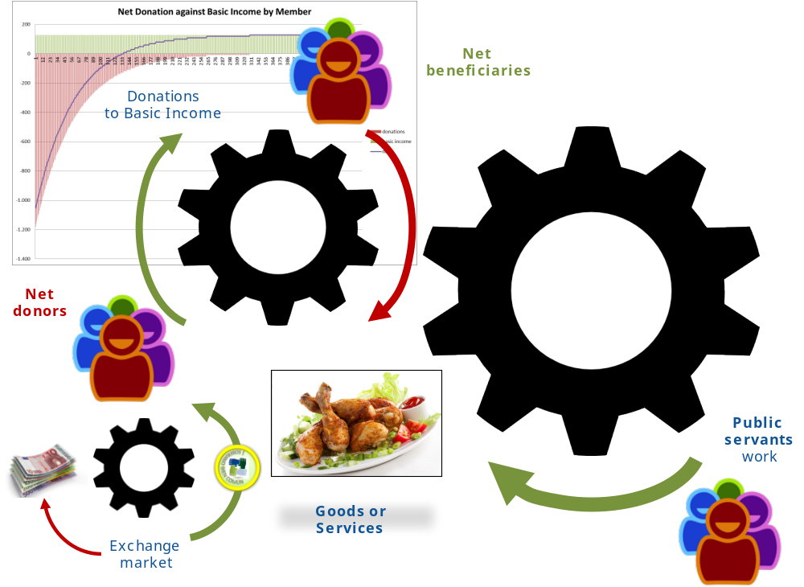
The net effect to be obtained is to give access to the less wealthy, the net beneficiaries of the Equalitarian Peoples Association, to goods and services worth much more than the value of the donations. The mechanism is to create an internal market in Common Sovereigns currency that is bigger than the public services.
- Net beneficiaries of the Basic Income, with no stable working contract in the external world, have access to goods and services for the amount of their net basic income after taxes. They may offer also their services in the internal market and get extra incomes in Commons Sovereigns.
- The public servants low egoist ratio ensures a devaluation of the Common Sovereigns with respect external money. It translates that the donations made by the richest with a low effort in external money like USD or EUROS, translates in a multiplied purchasing power at the internal economy.
- Additionally, the goods or services delivered by the Public Service Enterprises have subsidised prices cheaper than the market prices at the internal economy. It means that goods of public priority are even cheaper.

Contracts and interfaces

Interfaces

Wallet interface to the current accounts
Users:
- Members get a unique current wallet
- Public service enterprises get a unique current wallet
- The Council gets a current wallet named Peoples Bank
- Other corporations get a unique current wallet
Interface showing the history of transactions to the current account and the totals. Shows comments and invoice titles.
Operations
- Send: For sending an amount to another account.
- Ordering: To create an ordering contract out of a template.
Address book (private matching of anonymous accounts)
Units are Common Sovereigns of that Equalitarian Peoples Association

Wallet interface to the loan accounts
Users:
- Members get a unique wallet
- Nobody else has a loan wallet
Interface showing the history of transactions to the loan account and the totals. Shows loan contracts addresses.
Operations
- Create loan: To create a loan contract out of a template.
Address book (private matching of anonymous accounts)
Units are Common Sovereigns of that Equalitarian Peoples Association

Voting interfaces
It’s a voting interface for members. It shows the issue voted, the alternatives and a voting action.

Members registry

Anonymity versus identification
As the Equalitarian Peoples Association results into net transfer of wealth of persons that are wealthier in the external world to those less wealthy, in order to prevent fraud, like using double identities to get more benefits, a link has to be established between the ethereum account and the real person.

Devices
A person could use different devices. All should use the same ethereum account.

Registry in the blockchain
There is a registry of all current and past members at the Equalitarian Peoples Association constitution. It includes the correspondence to an external world ID. Possibly an OpenID is enough.
Members of the Council can add (pending the candidate’s signature), delete or modify the registry.

Systems
- Wallet interfaces should be available as Web, PC (windows, linux, mac) and mobile (android, OS, windows)
- Order contract, Loan contract and membership commitments should be available as Web, PC (windows, linux, mac) and mobile (android, OS, windows)
- Voring interface should be available as Web, PC (windows, linux, mac) and mobile (android, OS, windows)

For an easy start, mobile transactions could be provisional transactions to be synchronised with an ethereum client at a PC or web.

Contracts

Transaction contracts

Order contract
Content and parameters
Description of the good or service to be delivered. It can be used privately by members or by the public service bodies to order projects, operational costs or acquiring assets. It can be used by corporations.
- delivery dates
- payment schedule and amounts
All accounting in Common Sovereigns
Actions
Once signed by all parties, once the delivery is accepted, it results in transfers according to the payment schedule
Signatures
Two signatures at creating the contract, provider and client
The acceptance signature to trigger the payment schedule
Dispute mediation
A court verdict may result in payments or points of reputation in both directions

Loan contract
Content and parameters
Description of the usage of the loan
Description of the collaterals of the loan. If digital, address of the contract.
- principal payment schedule and amounts
- interest payment schedule and amounts
All accounting in Common Sovereigns
Actions
Once signed by all parties, it results on
- a transfer of the loan form the lender loans account to the borrowers current account
- transfers from the borrowers current account to the lender loans account according the principal payment schedule and amounts
- transfers from the borrowers current account to the lender current account according the interest payment schedule and amounts
Signatures
Two signatures at creating the contract, lender and borrower
The authorisation of an inspector (public servant) of the Public Service in charge of loans regulation.
In the case of the loan to the Peoples Bank the Council signs (automatically triggered)
Dispute mediation
A court verdict may result in payments or points of reputation in both directions

Membership fee and basic income commitments
Content and parameters
An explanation of the member of his / her capacity to pay fees or make donations
If the basic income quantity is adjusted to needs, an explanation of the member of his / her basic income needs (dependent persons)
Description of the periodic action plan of the Public Service in charge of collecting fees and paying the basic salaries, in short, the Donations Service. Address of the contract.
- payment schedule and amounts of membership fees and Basic Income
All accounting in Common Sovereigns
Actions
Once signed by the member it results on
- the notification of the amounts to the periodic action plan of the Donations Service draft contract
No further changes are admitted
The approval of the periodic action plan contract of the Donations Service with the Council triggers:
- transfers of the member current account to the current account of the Donations Service according the payment schedule
- transfers from the current account the Donations Service to the member current account according the payment schedule
- non-payment by the member results in loss of points of reputation (following penalties indicated in the action plan)
Signatures
The signature of the Donations Service (automatically triggered)
The signature of the member at accepting
Dispute mediation
A court verdict may result in payments or points of reputation in both directions

Employment at a public service
Content and parameters
Description of the post and the job, times to be worked, the Public Service and the post supervising the job
- payment schedule and amounts
All accounting in Common Sovereigns
Actions
- requests for approval by post supervising the job at the payment schedule and amounts
- transfers from the current account of the Public Service at the payment schedule and amounts
- In case of managerial posts or council member the assignment to the category manager or council member, resulting in the powers to sign contracts that require this signature
Signatures
- For non-managerial posts, the signature of a Public Service Manager
- For managerial posts, the signature of the Council, with some specific required votes of Council Members
- For Council Members, the approval by voting of all members of the periodic plan including his/her nomination. The contracts are automatically launched. There is no supervisor.
The signature of the member at accepting
- periodic approvals by the supervisor
Dispute mediation
A court verdict may result in payments or points of reputation in both directions

Planning contracts

Periodic Action Plan of the Public Service Enterprise
Content and parameters
Names of the members elected for the management posts
It has a budget consisting of incomes and expenses
- Incomes
  - In the particular case of the Donations Service, fees committed by members (summary and detailed list)
  - Funding by the Peoples Bank
  - Sales of services
- Expenses
  - In the particular case of the Donations Service, basic salary committed to the members (summary and detailed list)
  - The list of projects to be launched
  - The operational expenditures
  - The employees posts and their salaries (post by post)
  - The return to be paid to the Peoples Bank
It has assets: all the infrastructure belongings
Procedure: A new period is added as a modification to the previous plans contract.
All accounting in Common Sovereigns
Actions
Stage 1: appointing the managers
Triggers the draft of the employment contracts as managers
Stage 2: proposal of action plan
Opens the budget to be filled in by the managers
Stage 3: approval by the Council
Triggers
- the draft of the order contracts to be launched for the projects and the other costs
- the draft of the employment contracts as public servants (post by post)
- the automatic signature of all Membership fee and basic income commitments
Signatures
Stage 1: appointing the managers
The signature of the Council, with qualified votes as established in the Constitution
Stage 2: proposal of action plan
The appointed managers of the public service, with the qualified votes as established in the Public Body statute
Stage 3: approval by the Council
The signature of the Council, with qualified votes as established in the Constitution
Dispute mediation
A court verdict. A court verdict may result in payments. It may result in firing the management.

Periodic Action Plan of the Equalitarian Peoples Association
Content and parameters
It is an extension of the Periodic Action Plan of the Public Service Enterprise, with some particularities
Names of the members elected for the Council posts
It has a budget consisting of incomes and expenses
- Incomes
  - Money issued out of the nothing by the members for this period and lend to the Equalitarian Peoples Association (summary and detailed list)
  - Membership fees or taxes due by the members in this period and collected by the Equalitarian Peoples Association (draft summary obtained from the Donations Service planning; once voted, imposed to the Donations Service)
  - Other donations
  - Savings from previous period
  - Return to be paid of the loans of the members at the previous period
- Expenditures
  - The cost of the basic income (draft summary obtained from the Donations Service planning; once voted, imposed to the Donations Service)
  - Funding of each of the Public Service Enterprises
  - The operational cost of running the public bodies. It is the cost of the democratic process (debate systems, voting systems, social networking)
  - The Council Member posts and their salaries
  - Money in the Peoples Bank that is returned to pay the loans (summary and detailed list)
It has assets: 100% shares of the Public Service Enterprises
I holds the reputation of all members
Procedure: A new period is added as a modification to the previous plans contract.
All accounting in Common Sovereigns
Actions
Stage 1: Fixing the budget and budget lines.
The previous Council drives the debate to fix the next budget, granting the democratic process. It translates the debate and alternative proposals into drafts plans to be voted, until reaching majority
Stage 2: Appointing the next Council members
Triggers the draft of the employment contracts as Council members. The employment contract is signed by the old Council, granting the democratic process.
Other actions:
Propose to create or deactivate Public Service enterprises or change their statuses (they cannot be deleted as the history of transactions cannot be deleted)
Signatures
Stage 1: Fixing the budget and budget lines.
A majority of equal votes of the members of the Equalitarian Peoples Association as established in the Constitution
It triggers the draft loan contracts to all members to issue the money.
Stage 2: Appointing the next Council members (post by post)
A majority of equal votes of the members of the Equalitarian Peoples Association as established in the Constitution (post by post) amongst competing candidates
It signs the loan contracts to all members to issue the money.
Dispute mediation
A court verdict

Constitutional contracts

Public Service Enterprise statute
Content and parameters
Mission
Management posts
Voting rules
- Voting majorities or qualified votes required for the draft Periodic Action Plan
- Voting majorities or qualified votes required for the ordering contracts
- Voting majorities or qualified votes required for the employment contracts
Templates
- Ordering contracts
- Employment contracts
It includes, as a particular case of Public Service, the Council, in order to manage the Council Members salary
Actions
Change the statute
Signatures
A majority of equal votes of the members of the Equalitarian Peoples Association as established in the Constitution. Alternatively, the power can be given to the Council.
Dispute mediation
A court verdict

Equalitarian Peoples Association constitution
Content and parameters
Mission
Council member Posts at the Council
Voting rules
- Voting majorities or qualified votes required for each of the planning contracts
- Voting majorities to elect the Council Members
- Voting majority required to change the constitution
- Voting rules for recommendation of new members candidature
Courts guides
- Verbatim Guides for the Ombudsman to appoint Courts according the contract type to be judged (a Court is a temporary Public Service Enterprise). Guides to hire the Jury (employees).
- Verbatim Guides on criteria to be used by the juries according the contract type to be judged (until contracts can be made more clever)
Members registry (past and present)
Registry of Public Service Enterprises
Actions
Change the constitution
Signatures
To change the Members registry:
- Candidates: recommendations required
- Acceptance: the signature of the Council and the candidate
To change the Registry of Public Service Enterprises: statute approved and the signature of the Council
A majority of equal votes of the members of the Equalitarian Peoples Association as established in the Constitution for any other change
Dispute mediation
A court verdict

Inspirations and Signature
Inspirations behind the ideas above
THE DESPERADOS ALTERNATIVE ECONOMY https://sites.google.com/site/desperadostheory/home
Una Moneda para cada Bien: SISTEMA MONETARIO PARA LA ECONOMÍA SOLIDARIA http://books.google.be/books?id=NUDaAQAAQBAJ
More People's Republic of DOUG stuff... Andreas Olofsson http://youtu.be/oZVsIiQ1ME0
 | Desperado PEREZ  desperado.theory@gmail.com  http://desperado-theory.blogspot.be/  https://sites.google.com/site/desperadostheory/home

Reconocimiento-NoComercial-CompartirIgual
CC BY-NC-SA
Esta licencia permite a otros distribuir, remezclar, retocar, y crear a partir de esta obra de modo no comercial, siempre y cuando se dé crédito y licencien las nuevas creaciones bajo condiciones idénticas.

