GENERAL SPECIFICATIONS of HULL |  |  |  | DATE | 4/27/15
BOAT MANUFACTURER | Godfrey Marine
BOAT MODEL | FD226OB-REF
 |  | 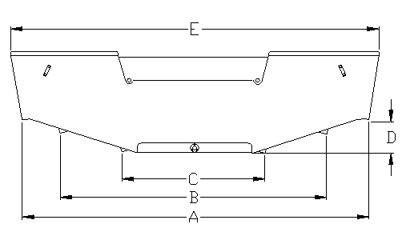
BOAT WEIGHT (DRY)
DEALER NAME
A - BOTTOM WIDTH OF BOAT | 79
B - OUTER CHINE | 51.5
C - INNER CHINE | 26
D - APPROXIMATE RISE OF BOAT | 4.5
 |  |  | Fulcrum point Approx. | 80
E - BEAM OF BOAT | 90.5 |  | ( bottom rear transom forward)
 |  |  | Max Fuel Cap.
G - LENGTH OVERALL | 266
 |  |  | Max. Battery(s)
H - BOW EYE TO TRANSOM/KEEL | 259
 |  |  | Max. Fresh Water
I - BOW TO TRANSOM/KEEL | 243
J - VERTICAL DIMENSIONS | 22
