GENERAL SPECIFICATIONS of HULL |  |  |  | DATE
BOAT MANUFACTURER | Godfrey Marine
BOAT MODEL | SS 188
 |  | 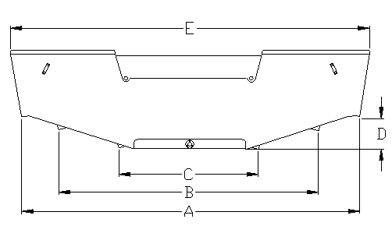
BOAT WEIGHT (DRY) | 2,600 lbs.
DEALER NAME
A - BOTTOM WIDTH OF BOAT | 86.5”
B - OUTER CHINE | 53”
C - INNER CHINE | 27”
D - APPROXIMATE RISE OF BOAT | 7”
 |  |  | Fulcrum point Approx. | 66”
E - BEAM OF BOAT | 100.5” |  | ( bottom rear transom forward)
 |  |  | Max Fuel Cap. | 36 gal
G - LENGTH OVERALL | 226”
 |  |  | Max. Battery(s) | 2
H - BOW EYE TO TRANSOM/KEEL | 206”
 |  |  | Max. Fresh Water | 13 gal
I - BOW TO TRANSOM/KEEL | 219.5”
J - VERTICAL DIMENSIONS | 20”
