This is all very frustrating.
I started with Xamarin for the first time this morning. I did a trial install and decided to start my education with the Tasky app.
So I unzipped this and tried to run it. I got this error
Error 1 Cannot find `aapt.exe`. Please install the Android SDK Build-tools package with the `C:\Users\Geoff\AppData\Local\Android\android-sdk\tools\android.bat` program. Tasky.Core.Android

So I followed the instructions contained in the message. Performing these Android downloads/installation took a very long time and filled my C: drive completely
So I backed off and restarted the whole process on a different PC (Still Windows 7 Professional)
Again I had to download using Android.bat – again it took a looooong time – but this time my disc was big enough!!

However after several hours of installation I still get this “Cannot find aapt.exe”

It is definitely on my disc in :- C:\Users\Geoff\AppData\Local\Android\android-sdk\build-tools\23.0.0\bin
This is a picture of Android.bat – so it seems that I have the correct and latest SDK Tools, Platform Tools AND Build Tools

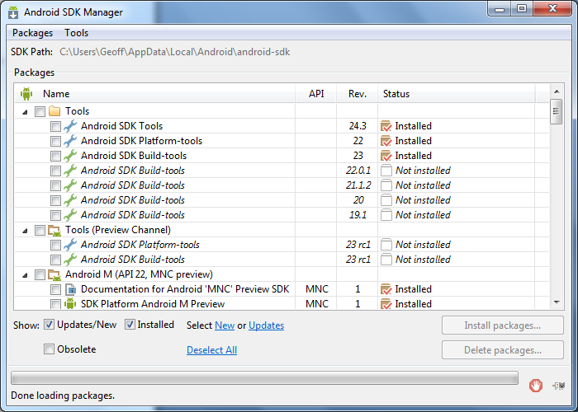

Microsoft Visual Studio Professional 2013
Version 12.0.30723.00 Update 3
Microsoft .NET Framework
Version 4.5.50938

Installed Version: Professional

LightSwitch for Visual Studio 2013 06177-004-0446025-02687
Microsoft LightSwitch for Visual Studio 2013

Team Explorer for Visual Studio 2013 06177-004-0446025-02687
Microsoft Team Explorer for Visual Studio 2013

Visual Basic 2013 06177-004-0446025-02687
Microsoft Visual Basic 2013

Visual C# 2013 06177-004-0446025-02687
Microsoft Visual C# 2013

Visual C++ 2013 06177-004-0446025-02687
Microsoft Visual C++ 2013

Visual F# 2013 06177-004-0446025-02687
Microsoft Visual F# 2013

Visual Studio 2013 Code Analysis Spell Checker 06177-004-0446025-02687
Microsoft® Visual Studio® 2013 Code Analysis Spell Checker

Portions of International CorrectSpell™ spelling correction system © 1993 by Lernout & Hauspie Speech Products N.V. All rights reserved.

The American Heritage® Dictionary of the English Language, Third Edition Copyright © 1992 Houghton Mifflin Company. Electronic version licensed from Lernout & Hauspie Speech Products N.V. All rights reserved.

Application Insights Tools for Visual Studio Package 1.0
Application Insights Tools for Visual Studio

ASP.NET and Web Tools 12.3.50717.0
Microsoft Web Developer Tools contains the following components:
Support for creating and opening ASP.NET web projects
Browser Link: A communication channel between Visual Studio and browsers
Editor extensions for HTML, CSS, and JavaScript
Page Inspector: Inspection tool for ASP.NET web projects
Scaffolding: A framework for building and running code generators
Server Explorer extensions for Microsoft Azure Websites
Web publishing: Extensions for publishing ASP.NET web projects to hosting providers, on-premises servers, or Microsoft Azure

ASP.NET Web Frameworks and Tools 2012.2 4.1.21001.0
For additional information, visit http://go.microsoft.com/fwlink/?LinkID=309563

ASP.NET Web Frameworks and Tools 2013 5.2.20703.0
For additional information, visit http://www.asp.net/

Common Azure Tools 1.2
Provides common services for use by Azure Mobile Services and Microsoft Azure Tools.

Microsoft Azure Mobile Services Tools 1.2
Microsoft Azure Mobile Services Tools

NuGet Package Manager 2.8.60318.734
NuGet Package Manager in Visual Studio. For more information about NuGet, visit http://docs.nuget.org/.

Office Developer Tools for Visual Studio 2013 ENU 12.0.30626
Microsoft Office Developer Tools for Visual Studio 2013 ENU

PowerShell Tools 1.2
Provides file classification services using PowerShell

PreEmptive Analytics Visualizer 1.2
Microsoft Visual Studio extension to visualize aggregated summaries from the PreEmptive Analytics product.

SQL Server Data Tools 12.0.30919.1
Microsoft SQL Server Data Tools

Windows Phone 8.1 SDK Integration 1.0
This package integrates the tools for the Windows Phone 8.1 SDK into the menus and controls of Visual Studio.

Workflow Manager Tools 1.0 1.0
This package contains the necessary Visual Studio integration components for Workflow Manager.

Xamarin 3.11.458.0 (7acdedd)
Visual Studio extension to enable development for Xamarin.iOS and Xamarin.Android.

Xamarin.Android 5.1.1.0 (3518c4ceb984ffea1f5d972ea9c09eb27738d565)
Visual Studio plugin to enable development for Xamarin.Android.

Xamarin.Forms Intellisense 1.0
Provides intellisense for Xamarin.Forms in the XML editor.

Xamarin.iOS 8.10.0.0 (7741cc495ab0baf04ff0405d0604bc27f0ecae2e)
Visual Studio extension to enable development for Xamarin.iOS.

Xamarin.iOS Unified Migration 1.0
Automated migration for Xamarin iOS Classic projects to Unified

Xamarin.TestCloud.Integration 1.0
Early preview of Xamarin Test Cloud integration

Log:-

Xamarin.VisualStudio.Shell.XamarinShellPackage Information: 0 : [2015-06-01 17:19:16.9] Initial entitlements: iOS Trial
Xamarin.VisualStudio.Shell.XamarinShellPackage Information: 0 : [2015-06-01 17:19:17.4] Running license sync for iOS
Xamarin.VisualStudio.Shell.XamarinShellPackage Information: 0 : [2015-06-01 17:19:17.6] Initial entitlements: Android Trial
Xamarin.VisualStudio.Shell.XamarinShellPackage Information: 0 : [2015-06-01 17:19:17.8] Running license sync for Android
Xamarin.VisualStudio.Shell.XamarinShellPackage Information: 0 : [2015-06-01 17:19:19.5] Updated license: iOS Trial 01/07/2015 07:25:26
Xamarin.VisualStudio.Shell.XamarinShellPackage Information: 0 : [2015-06-01 17:19:19.7] Updated license: Android Trial 01/07/2015 07:25:26
Xamarin.VisualStudio.ProfilerSettings Verbose: 0 : [2015-06-01 17:19:25.8] BeginEdit
Xamarin.VisualStudio.ProfilerSettings Verbose: 0 : [2015-06-01 17:19:26.0] EndEdit
Xamarin.VisualStudio.ProfilerSettings Information: 0 : [2015-06-01 17:19:26.1] Settings successfully saved.
Xamarin.VisualStudio.TastyPackage Information: 0 : [2015-06-01 17:19:27.3] Hooked up SDB tracing adapter
Xamarin.VisualStudio.TastyPackage Information: 0 : [2015-06-01 17:19:27.6] Initialization finished
Xamarin.VisualStudio.Android.XamarinAndroidPackage Warning: 0 : [2015-06-01 17:19:27.9] Initializing Xamarin.VisualStudio.Android.XamarinAndroidPackage
Xamarin.VisualStudio.ProcessWrapper Verbose: 0 : [2015-06-01 17:19:28.6] -- Starting Process - 06/01/2015 17:19:26 --
Xamarin.VisualStudio.ProcessWrapper Verbose: 0 : [2015-06-01 17:19:28.7] Executable: C:\Users\Geoff\AppData\Local\Android\ANDROI~2\tools\android.bat
Xamarin.VisualStudio.ProcessWrapper Verbose: 0 : [2015-06-01 17:19:28.9] Arguments: list avd
Xamarin.VisualStudio.ProcessWrapper Verbose: 0 : [2015-06-01 17:19:29.1] -- Process Finished [-1] --

